**Concurrency and Threads Introduction**  
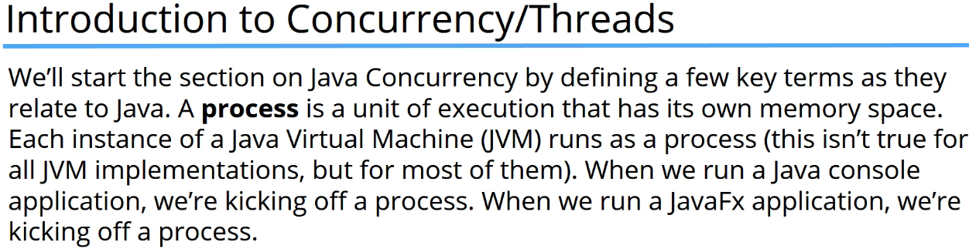

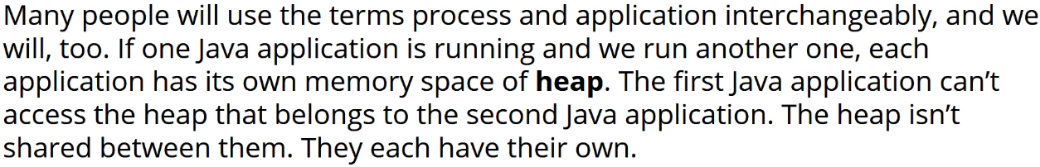

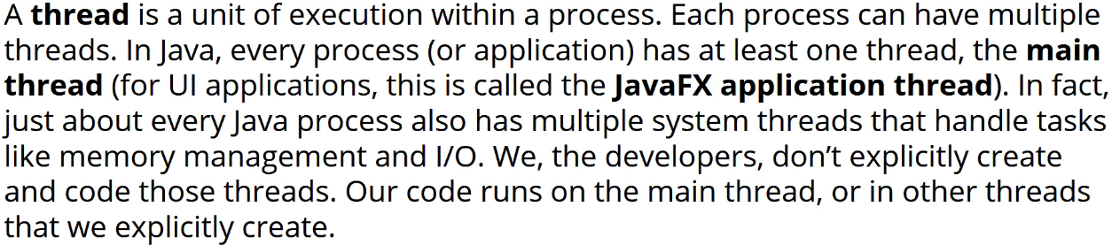

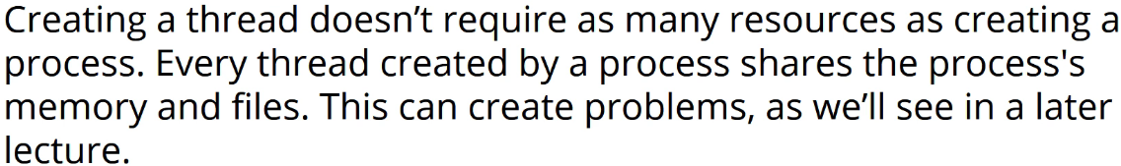

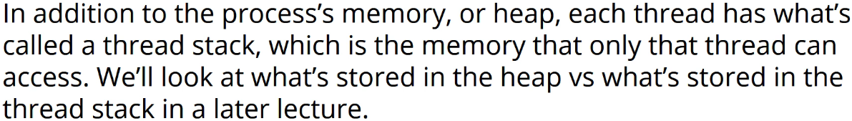

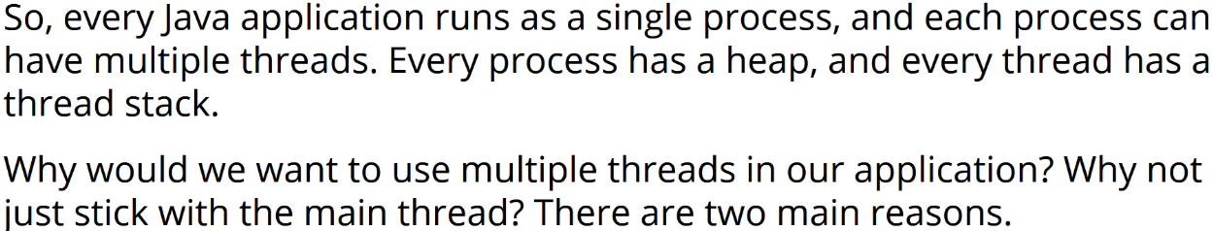

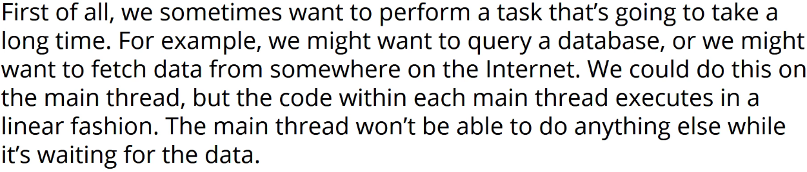

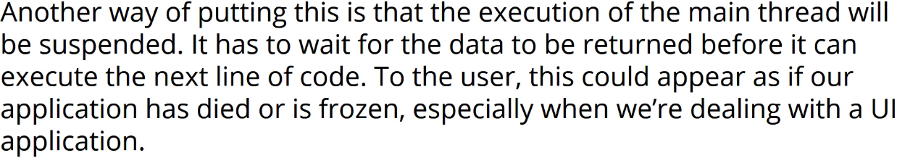

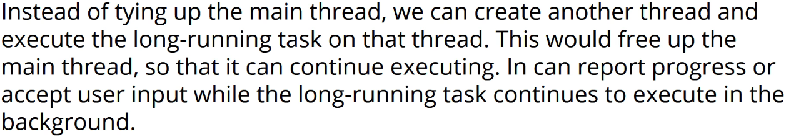

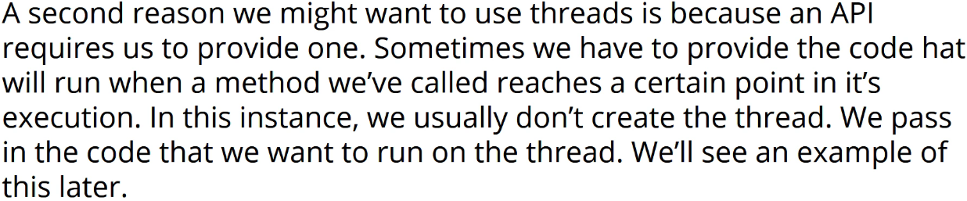

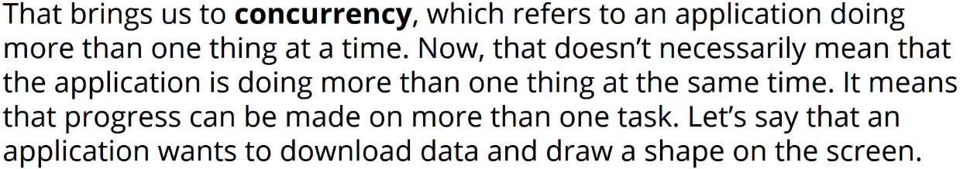

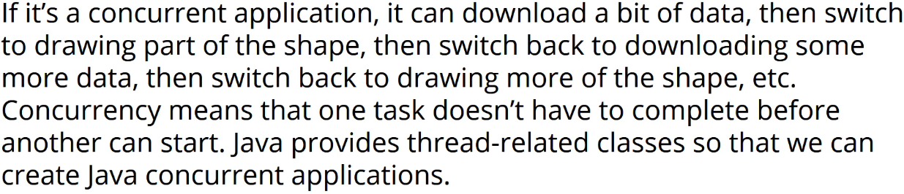



 **\* Because of that, output can vary from run to run and you might not see the exact same output that someone else sees when they run the application on their computer that uses concurrency.  
* For example we can’t guarantee in which order lines we printed to a console because of the very nature of threading itself.**

* **Process = application**  
* **Heap**  
* **Thread**  
* **Concurrency**

**Threads**  
* We can create a Thread in 2 ways:  
1) **Create an instance** **of the** **Thread class - create a subclass of the** **Thread** **class and then overriding the run() method**  
2) **Use the Runnable interface**  
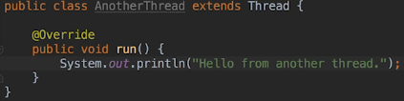

* **start()** => enables the JVM to run the **run()** method for the Thread.  
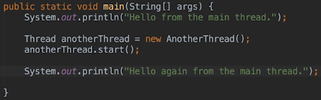  
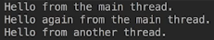  
* You can see that we might see the 2nd line from the main Thread printed before the other Thread and this is going to vary.  
* What we can do here is when we are dealing with Threads is keep in mind that it’s up to the system to schedule when the Threads will run and in relation to that, we can influence the order of execution by setting a particular Threads priority. But even with that said we can never assume that threads are going to run in a particular order.  
* Rather than creating a named class for the other Thread, we could also have created an anonymous class and this is useful if you’re only ever going to want to run the code once. In thata situation an anonymous class would work and is probably easy to configure but if you intended to run the same code several times, then creating a class for the Thread would make more sense and have a better result. Notice that I said RUN THE CODE several times and not START THE THREAD several times. Keep in mind that we’re not allowed to start the same instance of a Thread more than once. So in other words, if you create a subclass of Thread and you want to execute the code in the run() method more than once, then you have to create a new instance of the subclass every time you want it to execute. You can’t start a Thread instance that is already running in other words.  
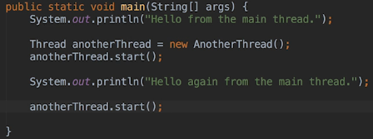  
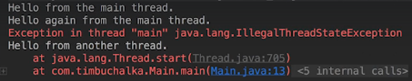  
* When we use an anonymous class, we have to start the Thread immediatelly so that’s another consideration when deciding whether to use a named or an anonymous class.  
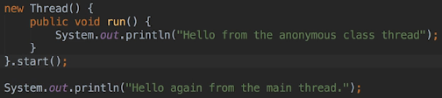  
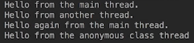

* I’m gonna use colors for the outputs now. It may not work on your operating system.  
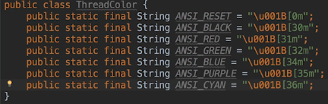  
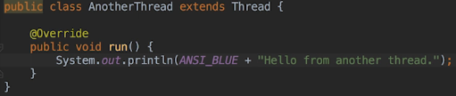  
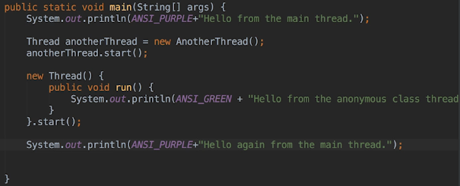  
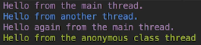  
* In the next video we’re going to talk about implementing Runnable which is a way to create Threads using another method. So the Runnable interface is another way of creating a Thread which really only requires us to implement 1 method.

**Runnable and Thread**  
* The 2nd way of creating a Thread is to use the Runnable interface.  
* The advantage of using that is that it only requires us to implement a single method.  
* **run()**  
* So instead of implementing the run() method of a class that sub classes Thread, we can have any class implement Runnable interface and then all we have to do is add run() method to that class.  
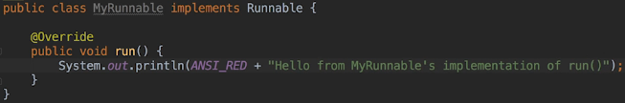  
  
* We can also have the anonymous class implement Runnable and pass an instance of it:  
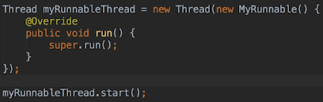  
* The question now you may have is why should we use Runnable VS sub classing the Thread class - in other words when should we use either way?  
=> **Most of the time developers use the Runnable way of doing things**. **The reason is that it’ more convenient and there’s also many methods in the Java API that want a Runnable instance passed to them**.  
* For example since the introduction of lambda expressions, it’s become even more convenient to use anonymous Runnable instances so when we have a choice because we’re not calling a method that requires one or the other, there isn’t reallyy a right or wrong answer but **most developers use a Runnable because it’s more flexible**.  
* **Thread terminates when it returns from its run() method either implicitly because it reaches the method’s end, or explicitly because it executes a return statement**.  
* **If you use run() instead of start(), then the code will run on the Thread that called it, not on a new Thread**.  
* **setName()** => sets a name for the Thread.  
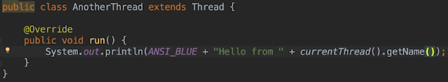  
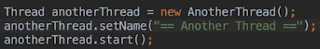  
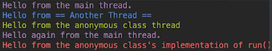  
* If we use run() instead of start(), we get:  
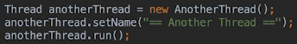  
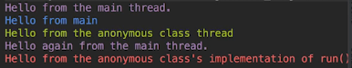  
* What else can we do with Threads when they’re running?  
=> **We can ask them to sleep or to stop executing for a specific amount of time**. You might want to do that to give other Threads the opportunity to run and you might also want the Thread to do something every time a specific amount of time has passed.  
* **For example we might wanna write something to a file every 15 seconds**.  
* **Or we might wanna check for data we’ve requested every 2 seconds**.  
* **We might also want the Thread to sleep when we know that it’s gotta wait for another Thread to do something and we know that the other Thread only does it every 10 seconds for example**.  
* **Thread.sleep()**  
* **InterruptedException**  
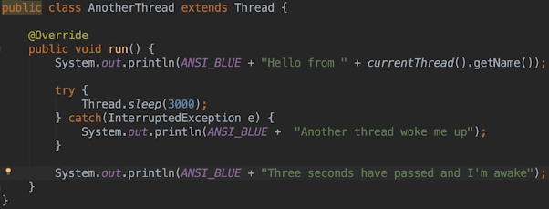  
* **It’s possible for a Thread to wake up prematurely because another Thread interrupts it**. When that happens, the InterruptedException is thrown.  
* **It’s important to note that it’s never guaranteed that the Thread will sleep for the interval we’ve specified**, it could be interrupted just as we discussed. Also the JVM has to call the underlying operating system to put the Thread to sleep and it’s possible that the operating system may not support the granularity that it’s asking for. For example it may not support nano seconds. So it’s really operating system dependant and operating system and JVM independent as to how long that’ll be.  
* **We interrupt a Thread when we want it to stop what is was doing and to do something else**.   
* **More often than not when you do that, you’ll interrupt the Thread because we want it to terminate**.  
* Example: suppose we’ve got a Thread that is monitoring a buffer for data that another Thread is fetching. So when the other Thread determines that there will never be any more data to fetch for whatever reason, we can interrupt the monitoring Thread and then it will terminate.  
* There’s 2 ways for Threads to notice they’ve been interrupted:  
**1)** **Catch the InterruptedException**   
**2)** When the run() method doesn’t call any methods that throw InterruptedException, it should call the **interrupted()** method periodically to check whether it’s been interrupted and that method will return true when another Thread has interrupted it. **How does one Thread interrupt another? When it calls the interrupt() method on the Thread instance that it wants to interrupt**. Now of course that means it’ll need a reference to that Thread instance to be able to call the interrupt() method on the other Thread.

**Interrupt and Join**  
* Using RETURN to terminate the Thread when it gets interrupted:  
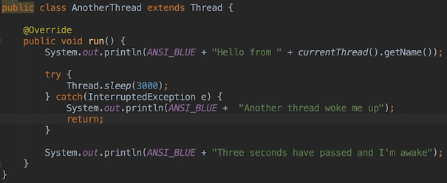  
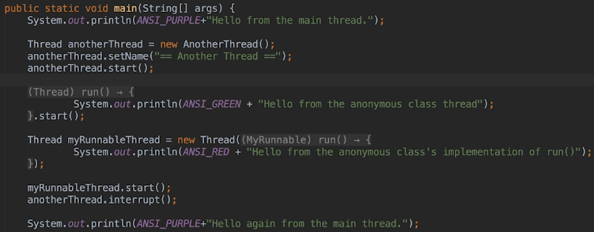  
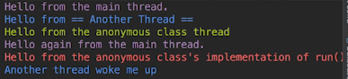  
* It finished quickly, didn’t sleep for 3 seconds.  
* For example we might know that there won’t be any data to process until the Thread that’s fetching the data has completed executing. So in that scenario rather than waking up the Thread periodically to see if there’s any data, we can join() the Threa to the Thread that’s fetching the data and when we join() a Thread to a second Thread, the first Thread will wait for the second Thread to terminate and then it’ll continue to execute.  
* It doesn’t matter whether we join() from a Thread instance we created using a Runnable or a Thread instance we created using a sub class of the Thread class. All we really need is a reference to the Thread that ultimately we wanna join() with.  
* **join()**  
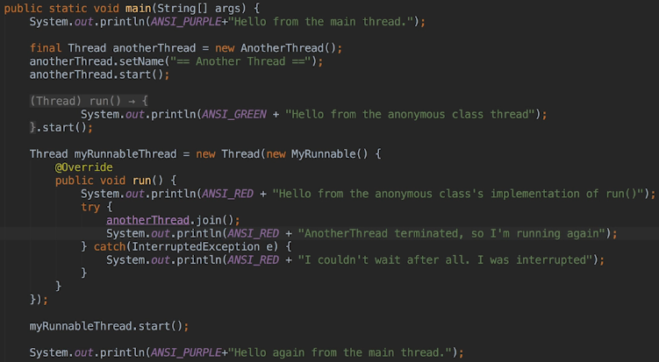  
* We’re calling the join() method of the Thread that we want to join the current Thread to.  
* join() can throw the InterruptedException and that’s because just like with the sleep() method, join() can terminate prematurely if this Thread is interrupted by another Thread.  
* When it comes to Threads, just as we can’t guarantee in which order they’ll execute, we also can’t make assumptions about how long Threads will sleep() or wait.  
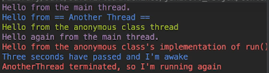  
* What would happen if we joined Thread A to Thread B and Thread B never terminates?   
=> Our application wouldn’t terminate and it would probably look as if it had actually died or crashes so to prevent this situation, we can pass a timeout value to the join() method.  
* **Let’s change the AnotherThread to sleep for 5000 seconds**.  


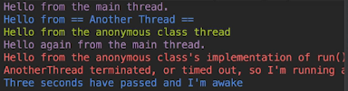

* In a real application when we join() one Thread to another Thraed and the join() times out, we have to handle that case - for example if the Thread was waiting for data and the join() times out, then we wouldn’t have any data to process and we have to somehow report that to the user.  
* There are other methods in the Thread class we can use but we ‘ve covered the ones that we’ll use the most.  
* The only other one I wanna mention is the:  
* **setPriority()** => we can use that to try to influence the order in which Threads are run but you should really regard setting a Thread’s priority is more of a suggestion to the JVM and the operating system rather than a command. In fact, some operating systems don’t support this setPriority() at all and will ignore it.  
* So as usual, never assume that setting priorities will force Threads to run in a particular order, it’s really ultimately up to the JVM and the operating system.  
* In the next video moving forward we’re gonna look at how working with Threads can lead to nasty bugs that can be very difficult to debug and ultimately show you how to get around those as well.

**Multiple Threads**  
* We’re gonna create 2 classes right inside of our Main class just because it’s a simple demo.  
* **Thread.currentThread()**  
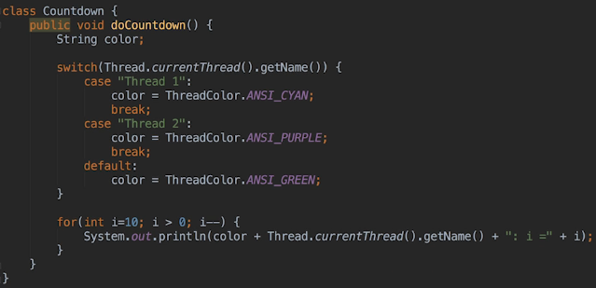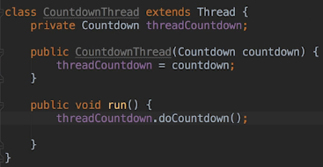  
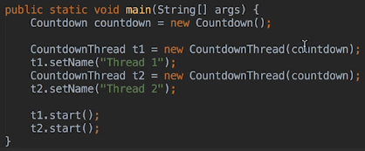 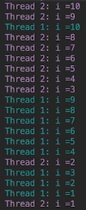 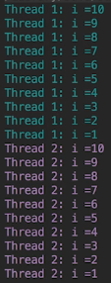 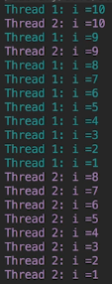

* You can see now looking at this how the system’s switching between the 2 Threads so we can’t predict when each Thread is run and will be suspended so everey time we run, we’re going to see a different result.  
* Now instead of using a LOCAL VARIABLE in the FOR LOOP, let’s use an INSTANCE VARIABLE = FIELD.  
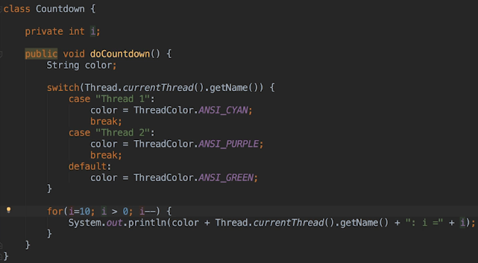 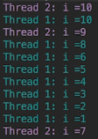 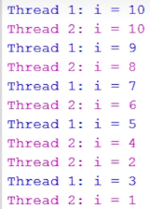  
* In this current run example you can see that Thread 2 skips all the numbers that Thread 1 prints and vice versa --- except for the number 10. And also Thread 1 prints 3 after Thread 2 prints 2. So what’s going on here?  
* Let’s talk about it in the next video.

**Thread Variables**  
* **Heap** - that’s the application’s memory that **all Threads share**.  
* Every Thread has a **Thread Stack** and that’s memory that **only that Thread can access**.  
* But they can both access the Heap.  
* **Local variables are stored in the Thread Stack, that means that each Thread has its own copy of a local variable**.  
* **In contrast, the memory required to store an object instance value is allocated on the Heap**.  
* We have to keep in mind that a FOR LOOP is actually SEVERAL STAMENTS  
=> The first time it’s executed, it assigns the initial value to the variable.  
=> It then checks to see whether the FOR CONDITION is met.  
=> If it is, the code within the loop is executed.  
=> When we return to the FOR STATEMENT, it will decrement i in this case and then check the condition again.  
* **Thread can be suspended between each step**, this is the key point, as an example a Thread could be suspended after the FOR has decremented the i variable but before the condition has been checked. Or it could also be suspended after executing all the code associated with the for loop but before executing the print line.

* Let’s list some potential suspension points here:  
1) Before decrementing i  
2) Before the condition   
3) Before printing out the value  
* There are actually more suspension points in this because the print line statement involves concatenation and IO and effectively calls multiple things but this is really a good enough understanding of what’s happening.  
* So all we can really be sure of is what the value of i was when each Thread printed it at that point in time.  
  
* So both Threads thought the value was 10 the first time they executed the print statement.  
=> That means that Thread 1 was suspended before it could decrement i from 10.  
* Now rather than each Thread being able to count down from 10 to 1, they keep skipping numbers because of the interference from the other Thread.  
* In fact when problems arise because Threads are interleaving and accessing the same resources, the situation has a name, it’s known as **Thread** **Interference = Race Condition**.  
* We’ll also see this situation referred to as a **Race Condition which is the more common term** for when 2 or more Threads are writing a shared resource.  
* **It’s important to note that there wouldn’t be a problem if both Threads were only reading the shared resource. Problem will only arise when at least 1 other Thread is writing or updating the resource**.  
* In our example where we see 5 4 2 3 it’s the case where the print statement itself has potential suspension points.  
  
=> Thread 1 prints the value of 5 and is then suspended.  
=> Thread 2 prints the value of 4 and is then suspended.  
=> Thread 1 decrements the value to 3, starts to execute the print statement, it builds the string that it’s going to print and at that point in time, the value of i is still 3 - Thread 1 calls print line and then is suspended while the print line method is executing but before the string is output to the console.  
=> Thread 2 decrements the value to 2 and prints it and is then suspended.  
=> Thread 1 continues to execute the print line method and prints out the string it created when the value of i was still 3 and is then suspended.  
=> Thread 2 decrements the value of i, then prints it out.  
=> Now that the value of i is 1, both Threads at this point exit the for loop and terminate.

**Synchronisation**  
* We could easily have both Threads count down without skipping numbers by not passing the same CountDown object to both Threads.  
* Both CountDown objects would be stored in the Heap but each Thread uses a different object.  
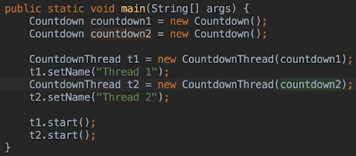  
* Now both Threads are successfully counting from 10 to 1.  
* But unfortunately this solution often won’t work in real world applications - as an example imagine if the objects were bank accounts or employee records. We can’t provide each Thread with a different object in this case. So every time a bank manager or employee file is accessed and changed, we have to use the same object to maintain the integrity of the data. In other words how do we know what the bank balance should be after several Threads have changed it? So in the case of bank accounts, there could be several Threads waiting to change the bank balance at the same time. Thre could be a Thread making an automatic deposit, perhaps a Thread making a scheduled bill payment and the owner of the account doing some online banking.  
* So in order to ensure the integrity of the bank balance value, **we need to allow multiple Threads to change it** but we also **need to prevent a RACE CONDITION** which is Thread Interference.  
* Fortunately, Java provides us with the way to control when a Thread can change a value in the heap. The process of controlling when Threads execute code and therefore when they can access the heap is called **Synchronization**.  
* So we can synchronize methods and statements.  
* When a method is synchronized, only one Thread can execute that at a time. So when a Thread is executing t he method, all other Threads that want to call the method or any other synchronized method in that class, will suspend until the Thread running the method exits it. Then another Thread can run a synchronized method.  
* To be clear if a class has 3 synchronized methods, then only one of these methods can ever run at a time and on only one Thread.  
* Now since only one Thread can execute a synchronized method at a time, Threads can’t interleave when running a synchronized method. **So that prevents Thread Interference within synchronized methods but not outside of those methods**.  
=> **So if the same instance variables reference within a synchronized method are also referenced outside it, in a place where multiple Threads can run and that particular code isn’t synchronized, then we may still see Thread Interference**.  
* **When working with Threads, we have to synchronize all areas where interference can happen**.  
* Let’s use 1 instance again:  
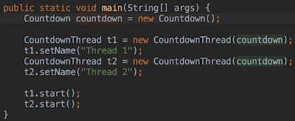

* **synchronized**  
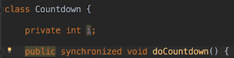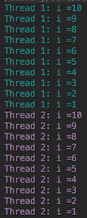  
* Unfortunately we can’t synchronize constructors and if you think about it, it wouldn’t really make sense if we could do that. Only one Thread can construct an instance and until the constructor has finished executing, the instance won’t be available for other Threads to use anyway.  
* But what we can do is synchronized any other method.  
* **That’s 1 way to prevent a RACE CONDITION**.  
* The 2nd way we can do that is to synchronize a BLOCK OF STATEMENTS rather than an entire method. Every Java object has what’s called its **Intrinsic Lock** and will also see this referenced to as a **Monitor**. **So we can synchronize a block of statements that work with an object by forcing Threads to acquire the object’s lock before they execute the statement block**.  
* **Only 1 Thread can hold the lock at a time so other Threads that want the lock will be suspended until the running Thread releases it**.  
* So what object will we use to synchronize the for loop?   
* We can’t use the counter variable i because it’s a primitive type not an object and primitive types don’t have Intrinsic Locks.  
* The first thought might be to use the color object to synchronize the for loop so let’s try that and see what happens.  
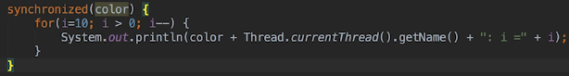  
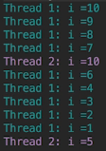  
* Clearly there’s still interference.  
* The problem here is that we’re using a local variable to synchronize and you recall that local variables are stored in the Thread Stack, each Thread will create its own copy of the local variable and each copy is an object that has its own lock.  
=> When we want to synchornize using an object, we have to use an object that Threads will share so that they’re both competing for the same lock. Using local variables as a result won’t work. The only exception to this is using a string variable and the reason for that is that string objects are reused within the JVM, in other words the JVM uses a string pool for allocation of string objects.  
* I’m only mentioning this now because you may see examples of a local string variable being used to synchronize code and you’ll be wondering why that works AND the synchronized code we’ve got here using the color local variable doesn’t work. So that’s really the only exception to the rule. As a general rule, it’s easy to just remember not to use local variables to synchronize full stop.  
* **I should reiterate that when using a local object variable, the object reference is stored in the Thread Stack but the object values are stored on the Heap**. Now since the Threads will each create their own copy of the object, the object references will then be different, there won’t be any interference even though the object values are in the heap. Essentially the Thread Stack will only ever contain primitive values and object references and to be fair function references, but that’s really outside the scope of this lecture and not related to race conditions.  
* So we can use **THIS** **to synchronize** it:  
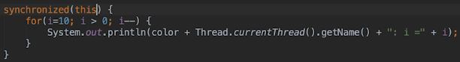  
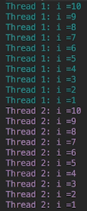  
* You can also synchronize static methods and you can also use static objects. When you do that, the lock that’s used is owned by the class object associated with the object’s class.

**Producer and Consumer**  
* Synchronization is reentrant - that means is that if a Thread acquires an object’s lock and within the synchornized code it calls a method that’s using the same object to synchronize some code, the Thread can keep executing because it already has the object’s lock. In other words a Thread can acquire a lock it already owns.   
* Now if this wasn’t the case, synchronization would be a lot trickier.  
* We’ll sometimes see the term **Critical Section** used when discussion Threads and synchronization. Critical Section just refers to **the code that’s referencing a shared resource like a variable**.   
* **Only one Thread at a time should be able to executing a Critical Section**.  
* We’ll also see the term Thread-safe used. When a class or a method is **Thread-safe**, it means that the developer has **synchornized all the Critical Sections within the code so that we as a developer don’t have to worry about the Thread Interference**.  
* So if we’re using a method or a class that isn’t Thread-safe, then the developer hasn’t added any synchronization. In that case we’d be responsible for adding synchronization if we want multiple Threads to be able to safely use the code.  
* One last thing to note befor we move on - when we’re synchronizing code, **we should synchronize only the code that must be synchronized**.

* We don’t want Threads to be suspended or blocked unnecessarily because that can affect performance of an application as well as the user experience. So we really want to keep the code we synchronize to an absolute minimum.  
* **So we can prevent Thread Interference = Race Condition by synchronizing Critical Sections**.  
* Let’s now look at methods that can only be called within synchronized code.  
* Namely the:   
**wait()  
notify()  
notifyAll()**  
* The Producer - Consumer is a classic example that demontrates the use of these methods.  
* We’re gonna be pretending that we’re dealing with reading and writing messages of some sort.  
* We’re gonna have 2 Threads. One that’s gonna produce messages and the other one that’s going to consume messages.  
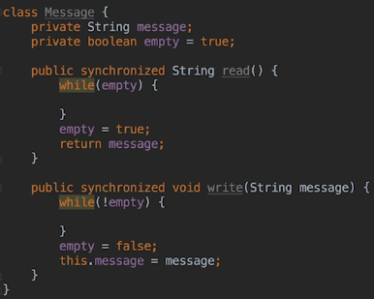  
* The read() method will be used by the consumer to read the message.  
* The write() method will be used by the producer to write a message.  
* The empty variable will be true when there’s no message to be read and we want the consumer to read each message before we write another one, so in the write() method we’re checking to see if the message is empty. If it isn’t, we’re gonna loop until the message is empty. When we exit the loop, we’ll set the empty to false and at that point we then write the message.  
* In the read() method, we’re gonna loop until there is a message to read.  
* **Random**  
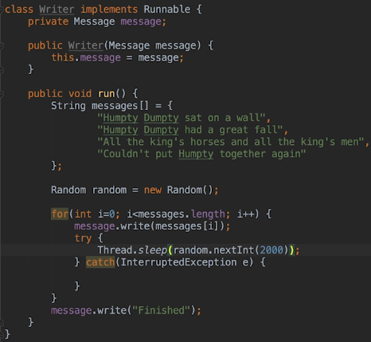

**Deadlocks, wait, notify and notifyAll methods**  
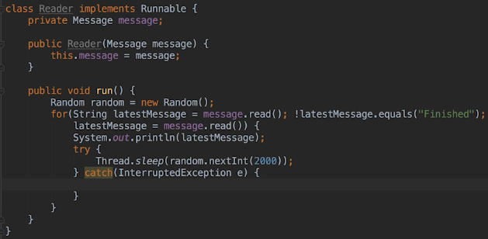  
* IntelliJ might offer you Writer and Reader so make sure you use your version.  
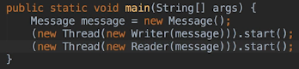  
* Let’s see what happens:  
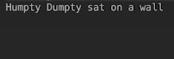  
* You can see there does seem to be a problem and this does depend on the timing but it is very likely when you run it you get a situation like this on my computer when you won’t see all the messages and the application appears to have hung.   
* So we need to terminate it now because clearly 2 seconds has elapsed and we’ve only got that very first message.  
* We’ve synchronized the read() and write() methods in our Message class. So what’s going on?   
=> The problem is that once one of the Threads starts looping, the other one can’t change the value of empty because the Thread is blocked. Remember that only one synchronized method can run at a time so the Thread that’s looping is holding the lock for the message object and the other one is blocked, waiting for the other Thread to release the lock.  
* This is what’s called a **DEADLOCK**. We’re gonna look at this situation in more detail in a later part of this section of the course.  
* We absolutely did need to synchronize both methods, so how do we actually get around this pr oblem?  
* This is where the wait() notify() notifyAll() methods come into play.  
* When a Thread calls the **wait()** method, it will suspend execution and release whatever locks it’s holding until another Thread issues a notification that something important has happened. So the other Thread issues the notification by calling the **notify()** or **notifyAll()** methods.  
* **We’re gonna call the wait() method inside the Message class’s read() and write() methods**.  
* **We’ll also have each Thread call notifyAll() after it’s changed the value of the empty variable**.

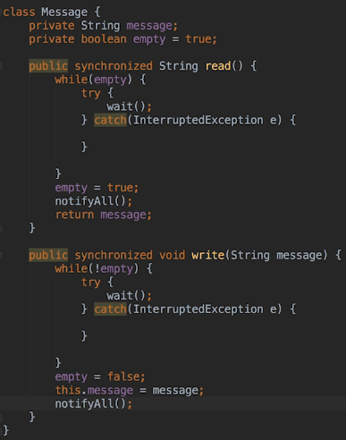  
* We’re still looping - now you might be wondering why do we have to loop - why not use an if statement and if that fails, call wait()?  
=> The answer is that we always want to call wait() within a for loop that’s testing for whatever condition we’re waiting on because when a Thread is notified to wake up, there’s no guarantee that it’s being woken up because the condition it’s waiting on has changed. So it’s possible the operating system has woken it up for another reason. Or it could have woken up because wait() threw an InterruptedException so we always wanna call wait() within a loop so that when it returns because there’s been a notification of some sort, we’ll go back to the beginning of the loop, we check whatever condition we’re interested in and then we call wait() again if the condition hasn’t changed.  
* So in other words never assume that a Thread has been woken up because the condition that it’s waiting on has changed.  
* Why calling notifyAll() rather than notify()?  
=> Well because we can’t notify() a specific Thread and that’s because the notify() Thread doesn’t accept any parameters. It’s conventional to use notifyAll() unless we’re dealing with a situation when there is a significant number of Threads, that all perform a similar task, waiting for a lock. In that case we don’t wanna wake up every Thread because when there’s a lot of them, that could result in a huge performance hit. So we call notify() so that only 1 Thread is woken up since all the Threads are waiting to do a similar task, whichever Thread is woken up should be able to proceed.  
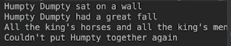  
* So each Thread now waits and releases its lock on the Message object when the loop condition passes and that gives the other Thread the opportunity to run. So it can now process a Message and change the value of the empty variable. When it calls the notifyAll() method, the Thread that’s waiting can now proceed.  
* So the 2 Threads go back and forth like this until all the messages have been printed.

* Let’s touch on 2 more points:

1) **When synchronizing code, always keep in mind that Threads can be suspended while executing a single line of code**. So a single line of code may call a method that contains hundreds of lines of code. OR a single line of code can contain many operations and the Thread can be suspended before or after each operation. So in the count down example you saw that the parameter we passed to the println method contained 2 method calls and 3 concatenation operations. As we saw, a Thread can be suspended before or after performing any of these operations and also while executing the println method itself. So having said that, there’s a few atomic operations in Java that happen all at once. A Thread can’t be suspended in the middle of doing them:  
=> Reading/Writing reference variables - for example the statement myObject1 = myObject2 would be atomic so a Thread can’t be suspended in the middle of executing that statement.  
=> Reading/Writing primitive variables except those of type long and double.  
* So the JVM may require 2 operations to read/write long/double and a Thread can be suspended between each operation for example a Thread can’t be suspended in the middle of executing myInt = 10 but it can be suspended in the middle of executing myDouble = 1.234.  
=> Reading/Writing all variables declared volatile but we will be looking at volatile variables in a future video in this section.

2) **In relation to the Collection classes - some Collections aren’t Thread-safe** so they’re not synchronized for example ArrayList is not Thread-safe. When we read the docs we see that it states that the implementation’s not synchronized. That means if we’re using an ArrayList in our application and multiple Threads can access that at the same time, we have to be responsible for synchronizing the code that uses the ArrayList. Alternatively after creating the ArrayList we can call **Collections.synchronizeList()** => and pass it to the ArrayList.   
* **So we still have to synchronize iterating over the list though**.

* On the other hand, the **Vector class is synchronized** so if we use the Vector class in our application, we wouldn’t have to worry about multiple Threads accessing the Vector object at the same time. So the **Vector class is Thread-safe**.

**The Java Util Concurrent package.**  
* To help developers write code that involves multiple Threads, the Java developers introduced the java.util.concurrent package in Java 1.5 along with several other sub packages.  
* These classes and interfaces in this package tree are there to help developers properly synchronize code and also make it easier to work with multiple Threads as well.  
* In this application there’ll be a Thread (Producer) that adds data to a buffer as well as 2 Threads that can read data from the buffer (Consumers).  
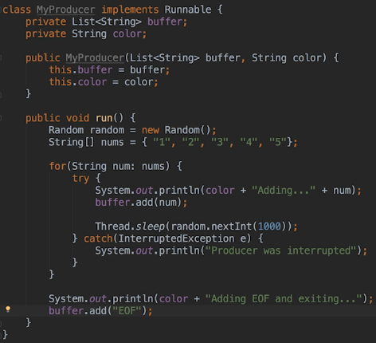  
* The buffer is gonna be shared by the consumers.  
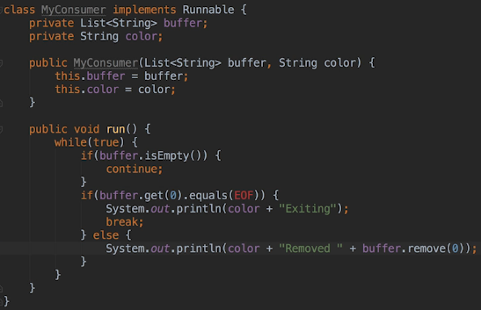  
* It doesn’t remove the EOF when it finds it because if it did, the other Threads would loop indefinitely, so that’s an important point there.  
* In a real world application we wouldn’t loop like that, we would have the consumer sleep for a while before checking the buffer again. Or we’d have a system that manages Threads and uses the wait() and notifyAll() methods.  
* Keep in mind this example is a contrived one and we’re keeping things simple so that we can focus on what we’re learning.

  
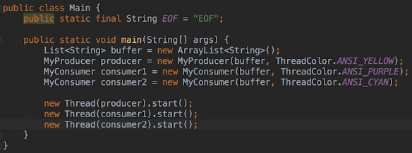  
* That EOF import is there so that the consumer/producer classes can use it without having to qualify it with a package and class name and

**Thread Interference**  
* Now we know we’re gonna run into problems with Thread interference, 3 Threads are sharing the same ArrayList, one’s writing to it, two are reading from it.  
* ArrayList:  
  
* So ArrayList is not Thread-safe.  
* 1 potential problem could be: the producer adds a string to the buffer, consumer1 calls isEmpty() and then that returns false or consumer1 is suspended or consumer2 calls isEmpty() and it returns false or consumer2 removes the string, consumer2 is suspended and consumer1 runs again and calls get(0) and oops, there’s no data so we get an IndexOutOfBoundsException.  
* There are other potential problems, another one would be both consumers try to remove the same string.  
* And again the point here is to remember that ArrayList isn’t Thread-safe so it’s certainly possible for one Thread to be suspended while in the middle of running the remove() method before the item has actually been removed from the ArrayList.  
* Let’s run it a few times:  
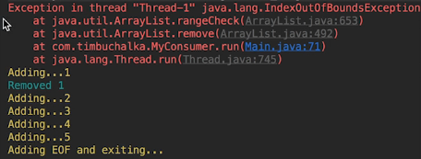 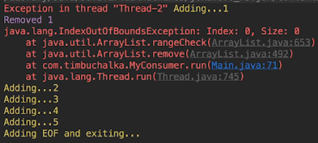  
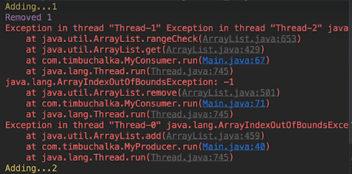  
* Let’s use what we’ve already learned, using the synchronized blocks. We’ll need to add synchronization to both the producer and the consumer and since they share the ArrayList, it probably makes sense to synchronize on the ArrayList instance.

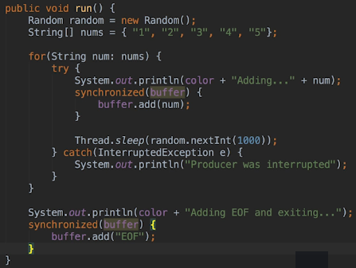  
* We don’t need to include the printLine and that’s because if the producer is suspended between printing the line and actually adding the data, it won’t matter. A consumer could read any existing data from the buffer in that case, it won’t change what the producer adds when it runs again.  
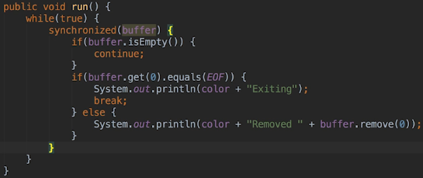  
* We don’t want the producer or another consumer to change the ArrayList once a consumer Thread has checked whether the buffer isEmpty(). So we want all calls to methods in ArrayList to take place as a unit collectively and they’re all running in this Critical Section.  
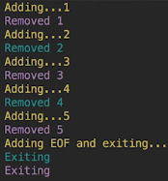 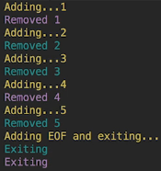 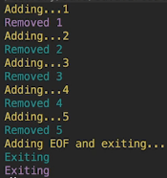  
* You can see that sometimes only 1 consumer Thread had the chance to remove the data and they’re both not necessarily getting the chance to remove the data each time.  
* Before Java 1.5 and the introduction of the java.util.concurrent package, synchronization was really the only error we had in our quiver when it came to dealing with Thread Interference. But it does still have its drawbacks.   
=> 1st drawback is that Threads that are blocked waiting to execute synchronized code can’t be interrupted. Once they’re blocked, they’re stuck there until they get the lock for the object the code is synchronizing on. And if you think about it, that can lead to problems and we’ll look at those later.  
=> 2nd drawback is that the synchronized block must be within the same method. In other words we can’t start a synchronized block in one method and end the synchronization block in another for obvious reasons.  
=> 3rd drawback is that we can’t test to see if an object’s intrinsic lock is available or find out any other information about that lock. Also if the lock isn’t available, we can’t timeout after we waited for the lock for a while. When we reach the beginning of a synchronized block, we can either get the lock and continue executing or block at that line of code until we get the lock.  
=> 4th drawback is that if multiple Threads are waiting to get a lock, it’s not first-come-first-served, there isn’t a set order in which the JVM will choose the next Thread that gets the lock. So the first Thread that blocked could be the last Thread to get the lock and vice versa.  
* So instead of using synchronization we can prevent Thread Interference using classes that implement the java.util.concurrent.locks.lock interface.

**Reentrant Lock and Unlock**  
* This package contains several implementations of the Lock interface that we can use.  
* The Lock implementations they provide don’t have the drawbacks that synchronized blocks have.  
* **ReentrantLock**  
* **Reentrant = if a Thread is already holding a reentrant lock when it reaches the code that requires the same lock, it can continue executing, it doesn’t have to obtain the lock again**.  
* Remember that all the Threads have to be competing for the same lcok to prevent Thread Interference.  
* **lock()**  
* **unlock()**  
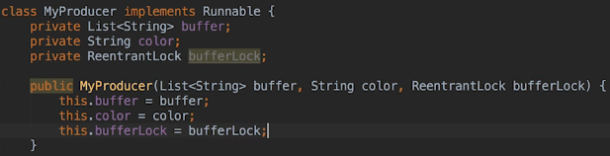  
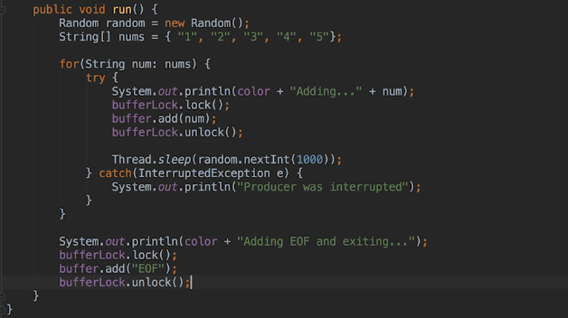  
* We’re using the lock() to acquire the lock and the unlock() to release the lock. This is very important. When using lock objects, we’re responsible for releasing the lock, it won’t happen automatically, it doesn’t happen automataically as it would when we use the synchronized block.  
* The intrinsic locks we use with synchronized blocks are always released when the Thread holding the lock exits the synchronized block. So this is 1 drawback to using lock objects in that we have to manage this lock process ourselves.  
* When a Thread calls the lock() method, it will either obtain the lock and continue executing, or it won’t be able to get the lock because a Thread already has it. In that case, the Thread that called lock() will be suspended until it can get that lock. If we forget to release the lock, Threads waiting for the lock will then start blocking forever.  
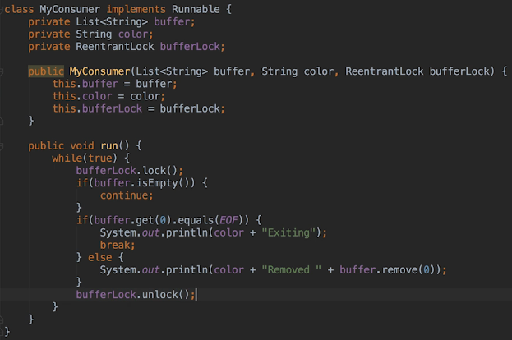  
* If we run it:  
  
* There a problem. If we leave it running long enough, we should probably get a Maximum lock count exceeded message with an Exception.  
* In the Consumer code we enter the loop and then we get the lock(). We then check to see if there’s any data in the buffer. If there is data, we can continue executing the loop code. If there isn’t, we loop back and get the lock() again because we’re still holding the lock. So the problem is we’ve never released the lock as such. So the unlock() code is never executed because that only runs after the while loop exits.  
* When we were using a synchronized block, the lock was released because we exited the synchronized block when we return to the beginning of the while loop. By just exiting the synchronized block, that automatically released the lock but when we’re using the lock object ourselves, we skip over the unlock() code and keep getting the lock again.  
* ReentrantLock objects can keep track of how many times they locked, if the Thread gets the same lock twice, it has to release it twice before another Thread can get the lock.  
* Here’s a pseudo example of what I mean:  
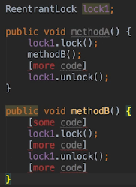  
* When methodB() calls unlock(), we wouldn’t want any other Threads to be able to get lock1 because methodA still expects to be holding the lock, surrounded a section of code with lock() and unlock() because the code itself is a Critical Section. Now because the same Thread can acquire the same lock multiple times, the unlock() method won’t actually release the lock until the lock count = hold count reaches 0.   
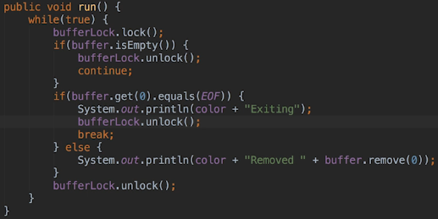 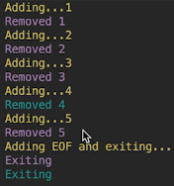  
* You might be thinking that this could get messy and perhaps you should be sticking with synchronized blocks.  
* But it’s only this messy because we’re not using locks in the recommended way.  
* I wanted to show you this so that we can see why we always want to enclose the Critical Sections of code with a TRY FINALLY block.

**Using Try Finally With Threads**  
* **We want to always enclose the Critical Sections of code within a TRY FINALLY block**.  
1) => **One reason for doing so is that we only need to call unlock() in one place**.  
2) => **The other reason is that it would be possible for code within a Critical Section to throw an Exception that we’re not explicitly handling using a catch statement and we want to make sure that we have released any locks we’re holding when that scenario plays out**.  
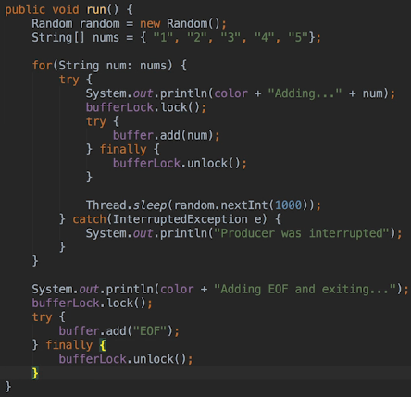  
* TRY FINALLY => there’s 2 advantages:  
1) We’ve only got to put the unlock() in one place - in the FINALLY clause  
2) IF we had another exception that somehow we weren’t processing/dealing with in the TRY block, the FINALLY clause code is going to be executed no matter what. That means we can pretty much guarantee that our unlock() is going to be called no matter what happens in the TRY block.

* If we try to release a lock we don’t own, we get an **IllegalMonitorStateException**.  
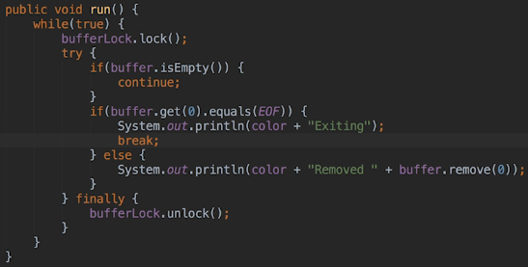  
* Now the program is working fine.  
* Let’s have a look at what else we can do with the locks.  
* A Thread can test to see whether a lock is available using the tryLock() method. If a lock is available, the Thread will acquire the lock and continue executing, if it’s not available, the Thread won’t block and alternatively can execute some different code.  
* For our particular application there’s no advantage of using tryLock() over lock() but let’s change the code to use it anyway.  
* **tryLock()**  
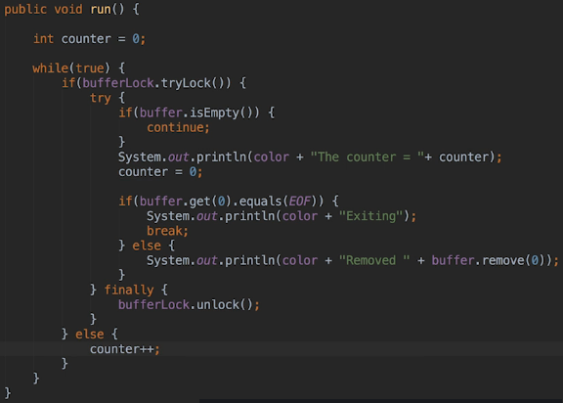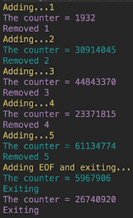  
* We can also set a **timeout period** in the tryLock().  
* Now we might want to see how many Threads are waiting for a lock before we try to acquire it. If there are already a lot of Threads waiting, we can run other code instead of blocking and waiting for the lock.  
* I mentioned that one drawback to using synchronized blocks is that they’re not first come first served, the lock interface doesn’t dictate this behavior either but some implementations do.  
* The ReentrantLock’s contructor accepts a fairness parameter. When it’s set to true, the ReentrantLock class wil try to be fair by giving the lock to whichever Thread has been waiting for it the longest.  
* Again if the Thread comes along and finds out that a hundred Threads are already waiting and it knows the lock is a fair lock, it might choose to terminate instead of blocking on the lock.  
* When using a ReentrantLock we can also check for the number of Threads waiting for the lock by calling the **getQueuedLength()** method.  
* In our application the producer Thread spends most of its time sleeping anad the Critical Sections of code for the consumers are executed very quickly so there wouldn’t be any Threads waiting for the lock most of the time.

**Thread Pools**  
* **ExecutorService** interface  
=> We use implementations of this interface to manage Threads for us so that we don’t have to expliciting create and start Threads.  
=> It manages things like Thread Scheduling, they also optimize the creation of Threads which can generally be expensive in terms of performance and memory.  
* We still have to provide Runnable objects to the service because we obviously have to code the tasks we want to execute on background Threads but we don’t directly manage any Threads as such. It allows us to focus on the code we want to run without the fuss of managing Threads and their life cycles.  
* Essentially we create an implementation of ExecutiveService and give it to the tasks we wanna run without worrying about the details of how the tasks will actually be run.  
* The ExecutorService implementations make use of **Thread** **Pools**. For this video all we need to know about Thread Pools is that the **Thread Pool is a managed set of Threads**. It reduces the overhead of Thread creation, especially in applications that use a large number of Threads. A Thread Pool may also limit the number of Threads that are active running and blocked at any one particular time.  
* When using certain types of Thread pools, an application can’t run wild and create an excessive number of Threads.  
* In Java, we use Thread Pools thought the ExecutorService implementations.  
* If we want to, we can actually implement our own Thread Pool by creating a class that implements one of the Thread Pool interfaces and by doing so, we can configure how the underlying Thread Pool ultimately is managed.  
* But it’s recommended that we use the implementations provided by the JVM in most situations.  
* Since Thread Pools can limit the number of active Threads, it’s possible that when we ask the service to run a task, it won’t be able to run it straight away. In that case the task will have to wait on the service’s queue until one of the active Threads actually terminates.  
* The **ExecutorService** interface extends the **Executor** interface which has only 1 method execute().  
* The **execute()** method is intended to be a replacement for this code:  
  
* So in this scenario what we do is:  
  
* r being Runnable.  
* As with the Lock interface, sub interfaces and implementations of Executor offer more functionality than the base interface and we can do a lot more when we use implementations of Executor like the ExecutorService that I’ve been talking about.  
* We have to use factory methods in the Executor’s class to create the instances that implement ExecutorService.  
* Now we can create several different types of ExecutorServices based on the type of Thread Pool that we want the service to use.  
* A fixed Thread Pool means that there’s only really ever going to be a specific number of Threads available to process tasks at any one time. If all the Threads are busy and more tasks are submit for execution, those tasks will just have to wait in a queue.  
* Let’s update our code so that it uses a fixed Thread Pool.  
* **Executors.newFixedThreadPool()**  
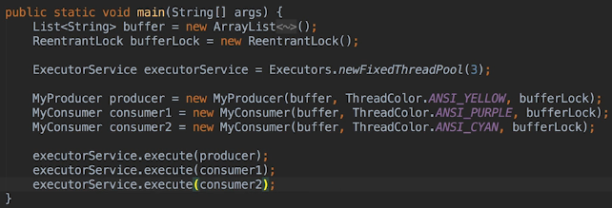  
* If we run it, everything seemed to work okay but notice the application doesn’t terminate, it keeps running.  
=> **We have to shut down the ExecutiveService when we no longer need it**.  
* **shutDown()**  
  
* **When shutdown() is called, the service will wait for any executing tasks to terminate**.  
* **shutDownNow()** => this would try to halt/throw away any remaining tasks, but there aren’t any guarantees that it will be able to do that.  
* It’s possible that some Threads will never terminate so it’s always best to try and shut down in an orderly fashion.  
* Using ExecutorService for this application is overkill but it’s vital for applications that use a large number of Threads because using them allows the JVM to optimize Thread management.  
* When we want to receive a value back from a Thread that we’re executing in the background, we can use the **submit()** method. It accepts a **Callable** object which is very similar to a Runnable object except that it can return a value. The value can be returned as an object of type **Future**.  
* **Future<String>**  
* **get()**  
* **ExecutionException**  
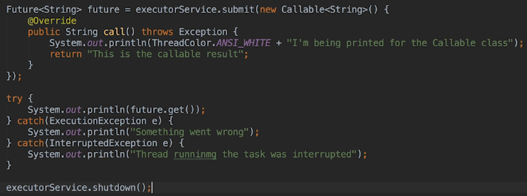  
* The call to the future get() method blocks until the result is available so when we’re calling it from the main Thread, our application will be frozen until the results are available so we wouldn’t use t his method in a UI application and in fact we wouldn’t use the services in the java.util.concurrent package in a UI application. When working with JavaFX we instead use the classes in the javafx.concurrent package to run tasks on background Threads and to process the results. The classes in the javafx package leverage the classes in the java.util.concurrent package in a way that makes sense for UI applications.

* **ArrayBlockingQueue Class**  
* Let’s now run the program:  
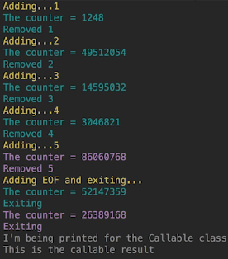  
* We can see that our producer and consumer Threads run and then the Callable code.  
* The Callable doesn’t run while the producer is sleeping and the consumers are looping because when we created the service, we passed 3 to the Executors.newFixedThreadPool() method - and so the service only allows 3 active Threads at a time. Consequently the Callable had to wait till the other methods are finished.  
* If we allow 5 Threads:  
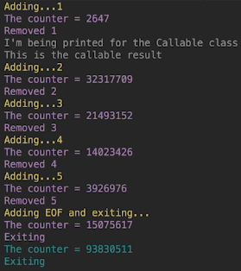  
* You can check the ExecutorService documentation for more information.  
* Let’s take a quick look at an example if another set of classes available in the package that allow us to simplify our application considerably.  
* The package contains Thread-safe queues which are perfect for a producer/consumer type of application.  
* All the queue classes implement the **BlockingQueue** interface.  
* We’re gonna change our example to use an **ArrayBlockingQueue**.  
* **It processes elements in a FIFO order - first in first out**.  
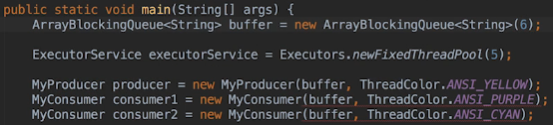  
* **As a result of this we no longer need the ReentrantLock**.

* ArrayBlockingQueues are **bounded** and that means that we have to pass in the number of elements the array should be able to hold - it’s capacity in other words, to the constructor, they don’t actually grow like ArrayLists do.  
* We’re gonna remove the bufferLock related code, we’ll also use buffer.put(num).  
* **put()**  
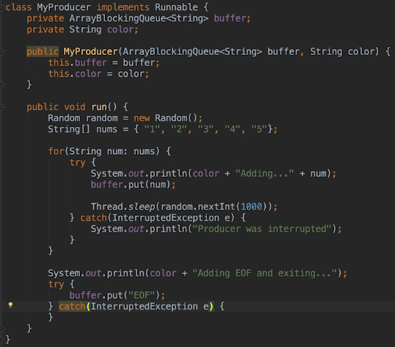  
* The **add()** and **remove()** methods would **throw an Exception if the operation can’t be performed immediatelly because another Thread’s got the queue locked**.   
* The **put()** and **take()** methods **will block when the queue is locked** so that’s the reason I’m using a put() there - **it’ll automatically block for us rather than throwing an Exception**.  
* **The same applies when the queue is full or empty**.  
* Now if we didn’t want to check for the EOF string without removing it from the queue, we wouldn’t need to call isEmpty() anymore, we could instead just call take() and block until something’s in the queue. But the method we use to check for EOF doesn’t block so we still need to take elements off the queue using 2 method calls. => Checking for empty and actually removing an element.  
* We want the producers/consumers to block when the queue is locked by another Thread and that’s why I’m using the put() method to add elements to the queue and shortly when I update the consumer class, I’m gonna use the take() method to remove elements from the queue.  
* You might also be wondering about synchronization with put() - well we don’t have to worry about synchronizing calls to put() because it’s a Thread-safe method.  
* You can see that doing this greatly simplifies the producer code but we still need to leave the catching because Thread can be interrupted while it’s blocked on a put() call so we have to handle InterruptedExceptions when we do call put().  
* Let’s now update the consumer code.

* **peek()** => we don’t need to specify the element.  
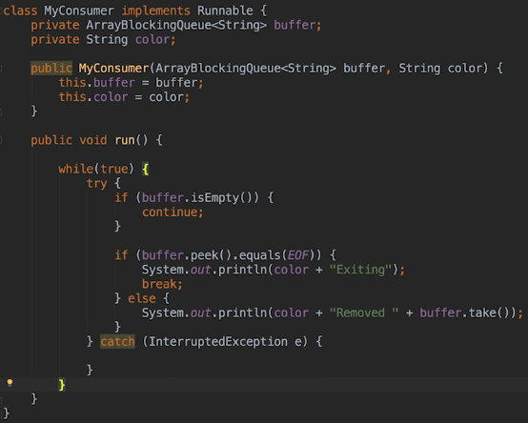  
* How come we don’t need to specify the element anymore?   
=> Remembering that the ArrayBlockingQueue is a FIFO, we don’t need to specify that we want the 1st element, it automatically knows to take that element out.  
* When we check for EOF using peek() method, it lets us look at the next element without actually removing it from the queue. Remember that we need to leave the EOF in the queue for the other consumer. The peek() method doesn’t block when the queue is empty, it returns null and that’s why we still have to check to see whether the queue is empty.   
* When we run our code:  
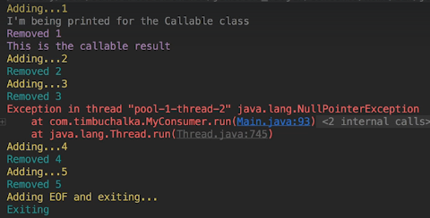  
* Remember that Thread-safe means that we can be confident that our call to one of the class methods will complete before another Thread can run a method in the class. So the producer code only calls the put() method and the code following the put() doesn’t depend on the result of the put(). However, in the consumer code what we’re doing is we check to see if the queue is empty, if it isn’t we then peek at the next element but the consumer Thread can be suspended between calling isEmpty and calling peek(). While it’s suspended, the other consumer Thread can run and take the next element from the queue. When the suspended consumer Thread runs again, peek() returns null and consequently we get a NullPointerException when we call the equals() method. That’s what happened in this scenario.  
* What that all means is that we may still have to add synchronization code when using Thread-safe classes like ArrayBlockingQueue.  
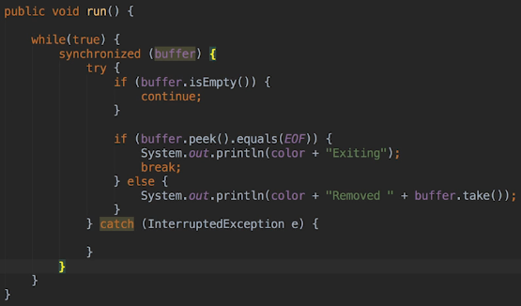  
* So we still needed some synchronization but by using one of the queues in the java.util.concurrent package, we didn’t have to synchronize the producer code at all.  
* So that’s it for the java.util.concurrent package.  
* Definitely look at the docs, there are many more classes and interfaces. Especially if you’re gonna work with synchronization and using a lot of Threads.  
* Next let’s look at some problems that can arise when working with Threads.

**Deadlocks**  
* A **Deadlock** occurs when 2 or more Threads are blocked on locks and every Thread that’s blocked is holding a lock that another block Thread wants. For example T1 is holding lock 1 and waiting to acquire lock 2 but T2 is holding lock 2 and waiting to acquire lock 1. Because all the Threads holding the locks are blocked, they will never release the locks they’re holding and so none of the waiting Threads will actually ever run.  
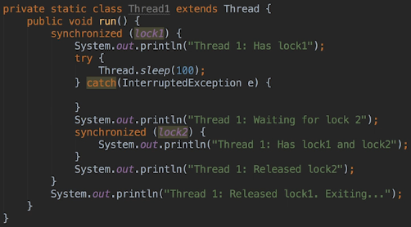  
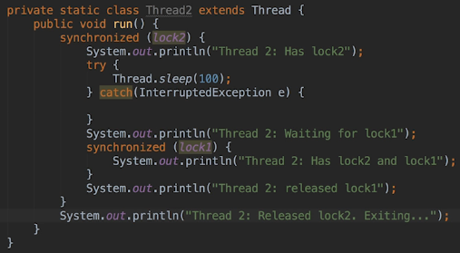

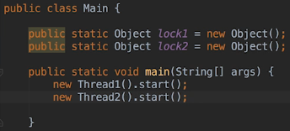 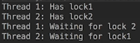  
* How can we prevent deadlock situations from happening?  
1) => One solution would be only ever try to lock on a single object and if you can write the code so that only one lock is required, the code won’t deadlock but unfortunately that is not a practical solution for many applications that need multiple locks.  
2) => The second way is to require that all Threads must first try to obtain the locks in the same order. The deadlock in our example is possible because Thread 1 tries to obtain lock 1 and then lock 2 and of course Thread 2 tries to obtain lock 2 and then lock 1. Now if we made both Threads obtain the locks in the same order, a deadlock can’t occur.  
* Let’s use the second solution:  
 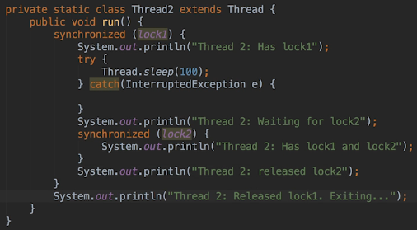 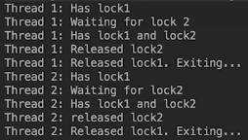  
* Once a Thread has obtained the outer lock, only that Thread can obtain the inner lock. It’s not possible for one of the Threads to hold one lock but not the be able to get the other lock. This is the key to avoiding deadlocks when 2 or more Threads will be competing for two or more locks.  
* **You wanna make sure that all the Threads will try to obtain the locks in the same order**.  
3) => Another solution would be to use a lock object rather than using synchronized blocks. So using the **tryLock()** method that we talked about previously with or without the timeout value will prevent deadlocks. But that will depend on the code

**More on Deadlocks**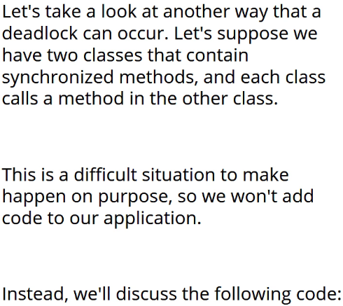

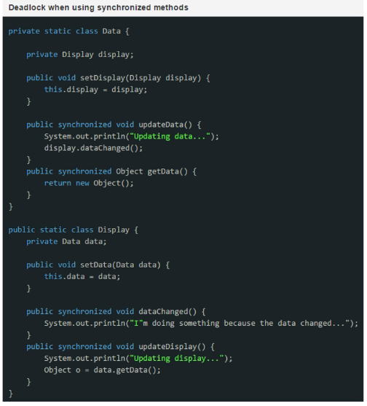  
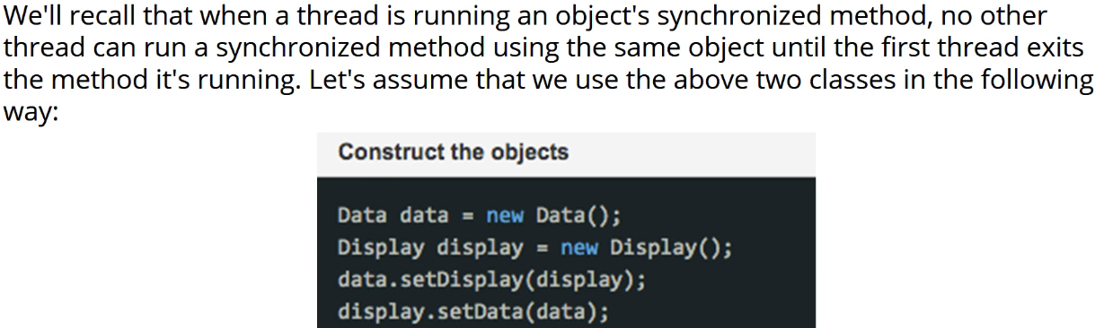

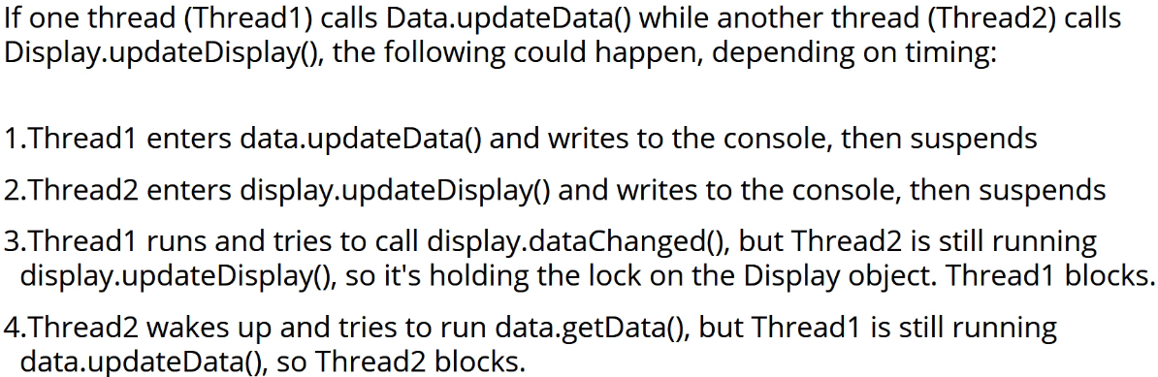

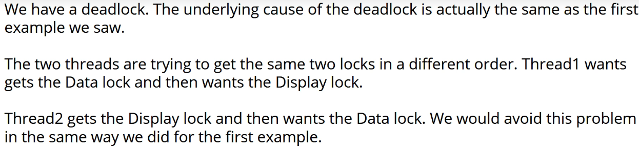

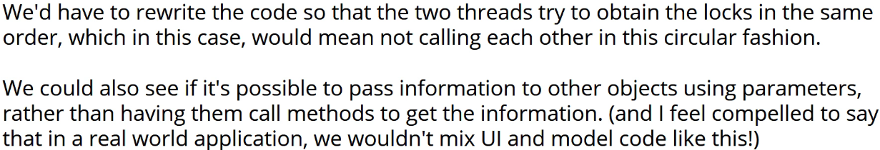

* Moving on.  
* **Let’s now see a deadlock that’s actually quite difficult to spot**.  
* **System.out.format()**  
* The only difference is that we can use **%s** which will be replaced with parameters in order.  
* The **%n** goes to a new line.  
* We’re using it here because it has a higher probability of deadlocking.  
* So when an object says hello, we want the other object to say hello back before another Thread can say hello to the same object.  
* Also we want an object to finish saying hello back to one object before it says hello back to another object so we synchronized the sayHello() and sayHelloBack() methods to do that.  
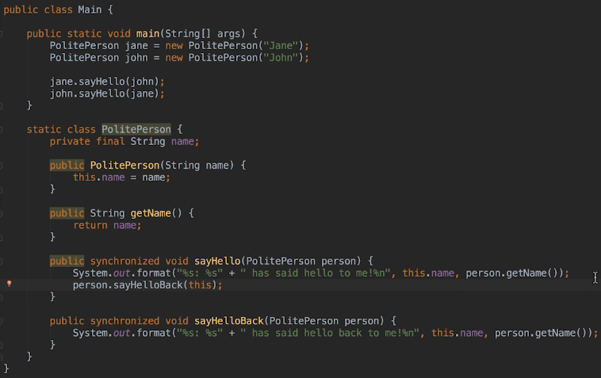

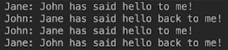  
* It’s running on the same Thread so we can’t actually experience a deadlock.  
* Because we’re using an inner class, the variable needs to be declared final.  
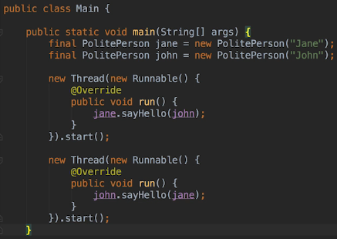  
  
* When a method is synchronized, won’t one Thread block until the other Thread’s finished executing the method?  
=> Yes, IF the Threads are calling the method using the same object. When we synchronize on a method, a Thread has to acquire the intrinsic lock for the object it’s using to call the method. In our example 2 objects are involved:   
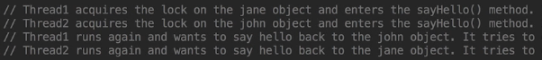  
  
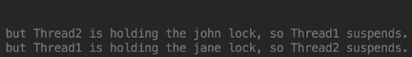  
* The potential for deadlock is more difficult to see here because we’re using objects passed as parameters so it’s not obvious that we could have multiple Threads trying to lock the same objects but in a different order.  
* Now imagine an application that uses perhaps hundreds of classes and uses hundreds of Threads. It would be very reasy for problems like this to sneak into the code if we’re not careful.  
* Once again the deadlock occurs because of the order in which Threads are trying to acquire locks.  
* That’s usually the underlying cause of a deadlock.  
* So when synchronizing code, always be on the lookout for places where this situation can arise.

**Thread Starvation**  
* When **Starvation** occurs, it’s not that Threads will never progress because they’ll never get a lock but tha they rarely have the opportunity to run and progress.  
* Starvation often occurs due to **Thread** **Priority**. When we assign a high priority to a Thread, we’re suggesting to the operating system that it should try and run the Thread before other waiting Threads.  
* Remember that when we use synchronized blocks, it’s not FIFO. When there’s more than 1 Thread waiting for a lock and that lock becomes available, the operating system won’t necessarily choose the Thread that has been waiting the longest to run. A Thread can block on the lock first but that doesn’t mean it will be the first Thread to run when the lock becomes available.  
* We’re going to use a static variable to synchronize our code.  
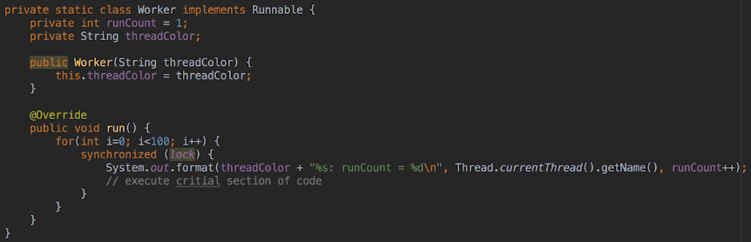  
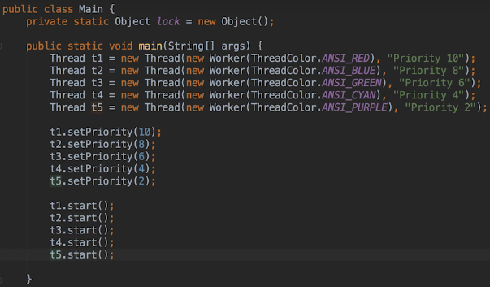  
* **setPriority()**  
* Keep in mind that the priority is only a suggestion to the operating system. It’s not actually binding in any way, we can never force the operating system to run Threads in a specific order.  
* It’s true that we’re passing a different worker object to each Thread but the lock object we’re using is static so in other words there’s only 1 instance of the object, all the Threads will be competing therefore for that one instance’s lock.  
* Also note that the lock on the object will be frequently released, giving any blocked Threads plenty of opportunity to run.  
* Let’s run and see what happens.  
* First run:   
P10 to 28  
P2 to 100  
P4 to 100  
P6 to 100  
P8 to 100  
P10 29 - 100  
* A Thread may only be suspended once in the middle of counting or not at all. In other words each Thread gets to run for quite a long time in computer time generally speaking, while the other Threads are stuck waiting.  
* The key takeaway to all this here is that although the lock is released frequently, often the highest priority Thread will probably hog all the time until it’s finished counting and the next Thread that runs won’t necessarily be the Thread with priority 8 and you obviously saw that happen.  
* Again, this is a trivial example so it doesn’t matter that one Thread hogs all the time but in a real world application the tasks that a Thread is performing might be long-running tasks. What if the run() method was performing database queries of file reads? If the Thread’s blocked there for seconds or even minutes because other Threads are always chosen to run when the lock becomes available, then the application’s performance will definitely be adversely affected.  
* Also, as we’ve just seen, setting a priority really is just a suggestion to the operating system.  
* If the task wasn’t so trivial, the effect on setting a priority might be more pronounced that’s the other thing to keep in mind because obviously all we’re doing is just a little bit of code here just sort of executing for the numbers 1-100 and looping through them.  
* So we’ve seen what Starvation can do, because the synchronized blocks aren’t FIFO, setting priorities can result in starvation. Threads can languish even when a lock is frequently released. Even when we don’t set priorities.  
* How can we prevent this starvation?  
* **When we’re dealing with deadlocks, the order in which locks are acquired was important**.  
**=> But for Starvation which Threads gets to run when a lock becomes available is important.**  
**=> So ideally we’d like things to be FIFO. Because we can’t dictate when Threads will run, we can’t guarantee a FIFO order but we can certainly do our best**.  
* In the next video we’re gonna actually talk about finding a way to get around this. Instead of using synchronized blocks we’re going to use something called a FAIR LOCK.

**Fair Locks and Live Locks**  
* We’ll use an alternative to synchronized blocks.  
* **Fair** **Lock** => fair locks try to be FIFO.  
* Previously we learned about using the ReentrantLock class which implements the Lock interface. The ReentrantLock implementation allows us to create Fair Locks. Not all Lock implementations do that, the interface doesn’t dictate that Locks have to be fair. So always read the docs.  
  
* A few important notes:  
=> Only fairness in acquiring the lock is guaranteed, not fairness in Thread scheduling, so it’s possible that the Thread that gets the lock will execute a task that takes a long time. So when using fair locks it’s still possible for Threads to still have to wait a long time to run.  
=> The tryLock() method doesn’t honor the fairness settings so it won’t be FIFO.  
=> When using fair locks with a lot of Threads, keep in mind that performance will be impacted. To ensure fairness, there has to be an extra layer of processing that manages which Thread gets the lock. So that can ultimately slow things down when there’s a lot of Threads competing for that lock.  
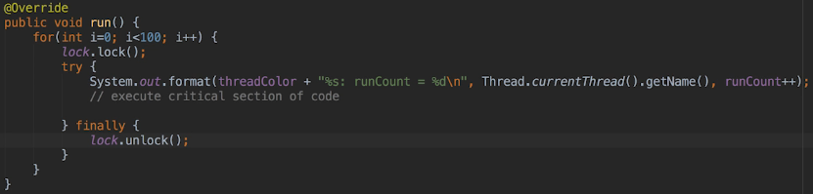  
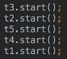  
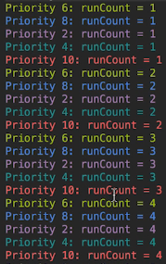  
* We get a far more consistent result.  
* We no longer have a starvation problem.  
* You might be wondering why you’d wanna use synchronized blocks.  
=> This is when knowing what you want to accomplish and knowing the application is very important.  
=> If you application only uses say 2 or 3 Threads or the tasks that you run on each Thread compete very quickly or you know from the application’s architecture that it’ll be rare for more than one Thread to be blocked on a lock at a time, then starvation may not actually be an issue for your code in that particular application.  
=> Also since using fair locks can impact performance, you might decide that starvation will be the lesser of two evils. For example you might have multiple Threads pulling data off the same queue and you don’t actually care which Threads pull up the data as long as it’s done quickly. In that situation using synchronized blocks would be preferable.

* Let’s now move on to another problem that can happen with Threads:  
* **Live** **Lock** => it’s similar to a Deadlock but instead of the Threads beeing blocked, they’re actually constantly active and usually waiting for all the other Threads to complete their tasks. Since all the Threads are waiting for others to complete, none of them can actually progress but they’re not blocked.  
* We’re gonna create 2 worker threads that share a resource, when they see that the other Thread’s active, they’re gonna give the resource to the other Thread and wait for it to finish using that resource.  
  
  
  
  
  
  
  
  
  
  
  
  
  
  
  
  
  
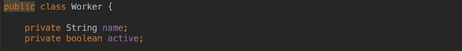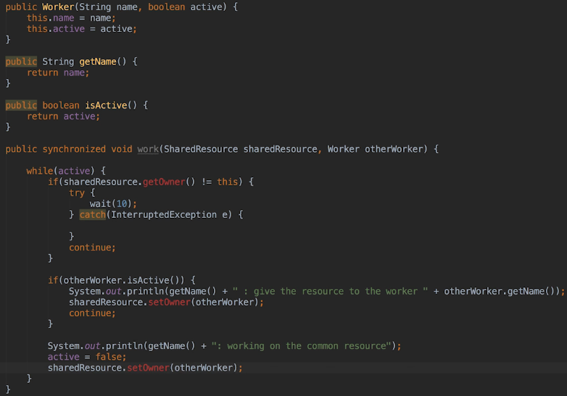  
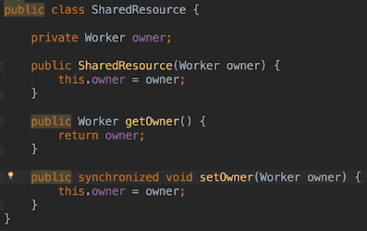  
* We don’t need to synchronize the getOwner() because it’s not changing any data.  
* The only time a Thread will complete the loop iteration is when it owns a SharedResource and the other Thread isn’t active.

**Live Lock Example and Slipped Conditions**  
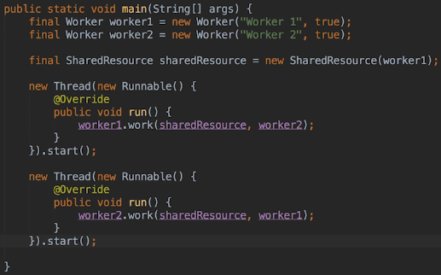  
* **When we construct the worker instances we’re passing true for active for both of them**.   
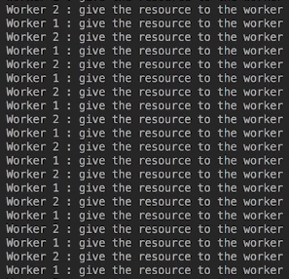  
* Since both workers are active, both keep handing the SharedResource to the other Threads and can’t actually make any progress.  
* Neither of them is blocked, they’re both constantly running or live, so hence the name Live Lock rather than a Deadlock.   
* A solution to this is going to depend on the code, there isn’t actually a solution where one size fits all answer here.  
* Anytime Threads have to wait for other Threads to complete something and they don’t block while they wait, there’s a potential for Live Lock.  
* Let’s talk about another problem that can occur:  
* **Slipped Condition**  
  


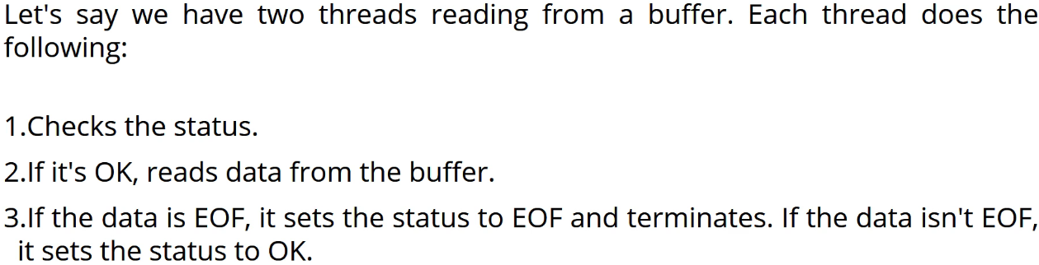

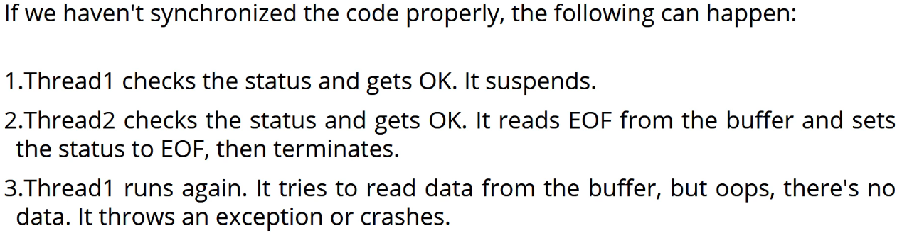

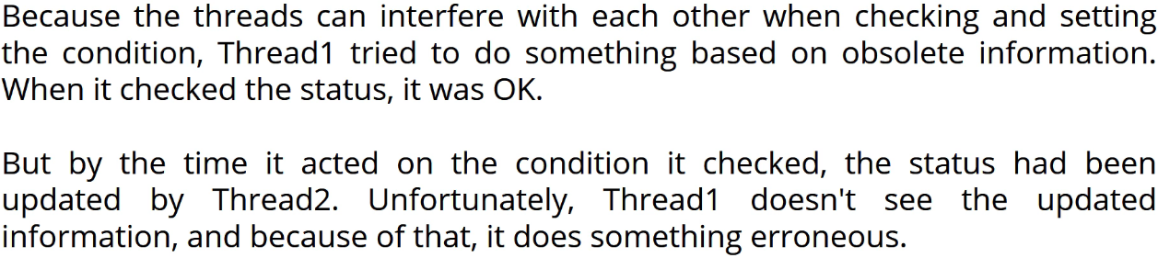

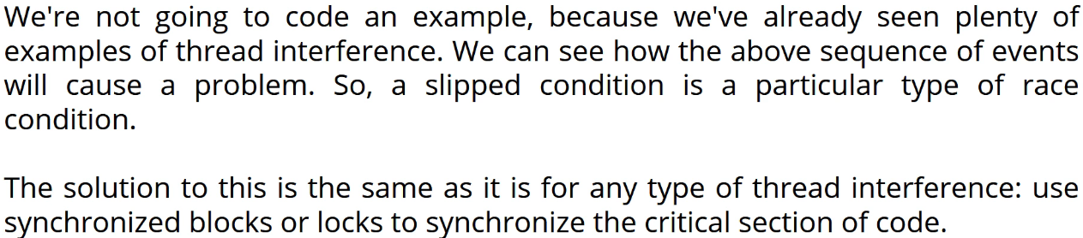

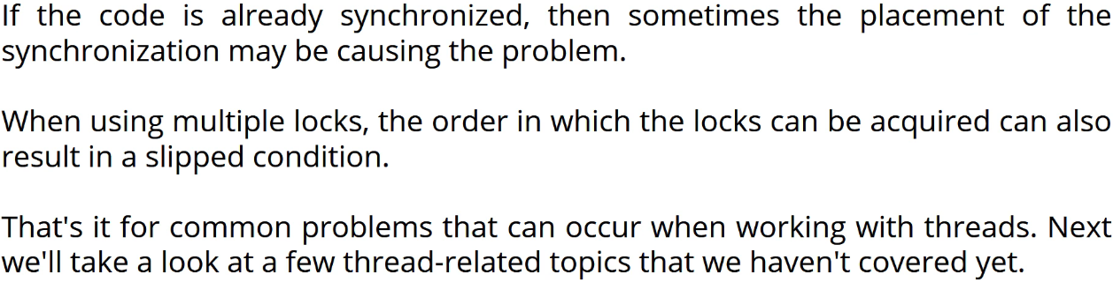

**Other Thread Issues**  
* Let’s cover a few loose ends related to Threads that didn’t sort of quite fit into the previous ones.  
* **Atomic Action**  
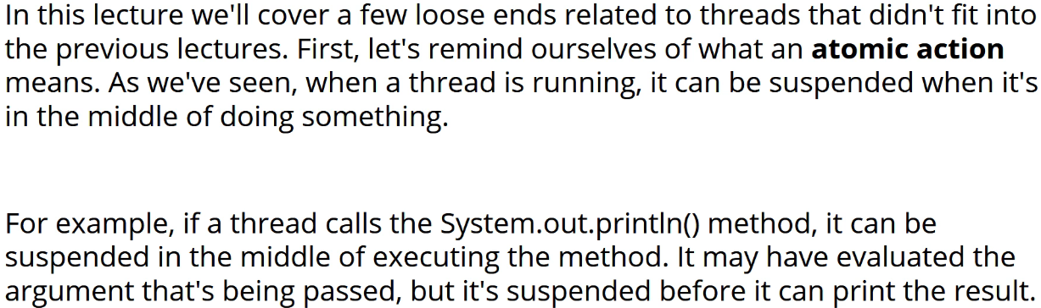

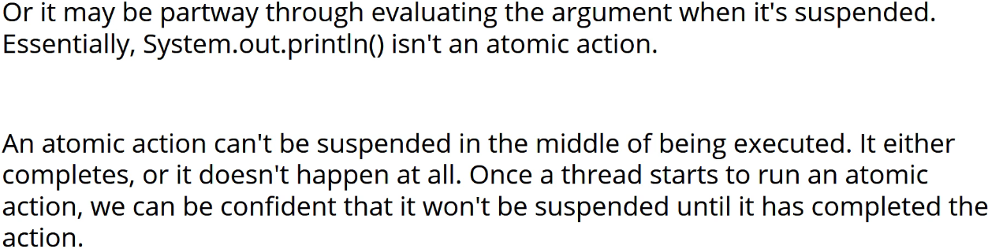

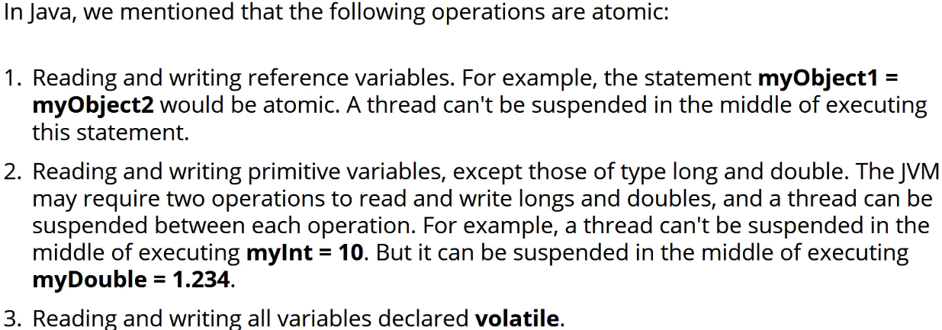

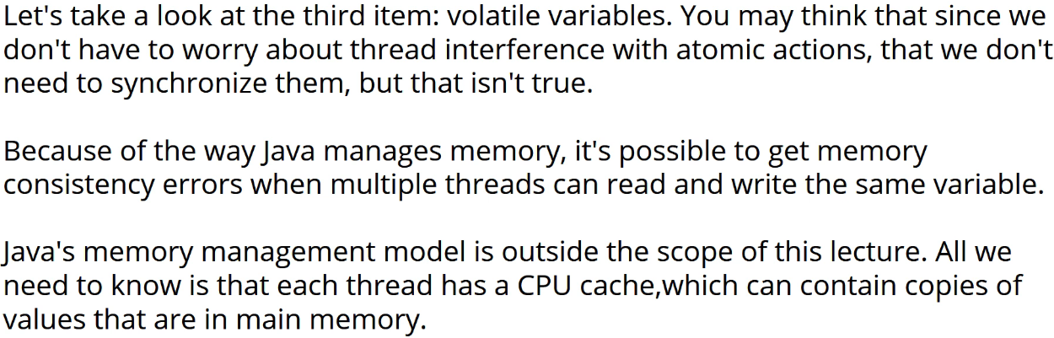

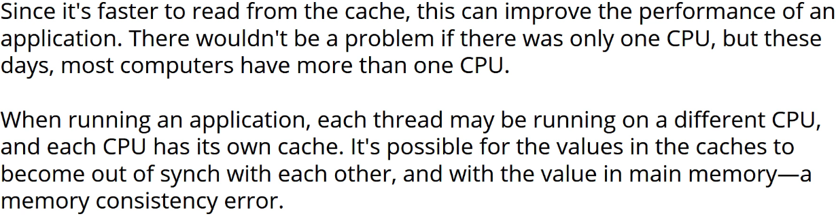

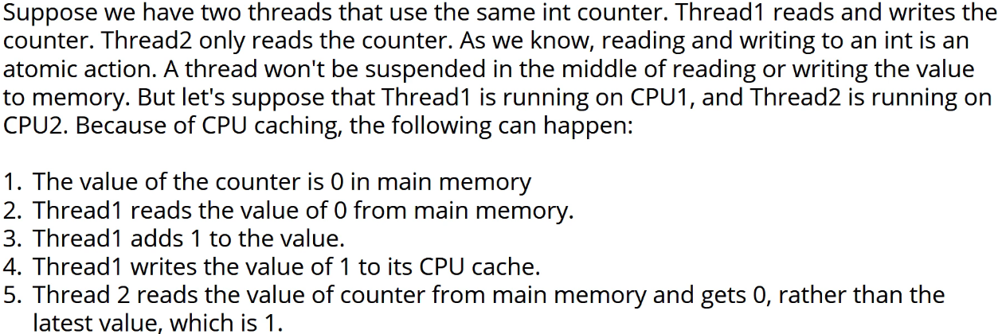

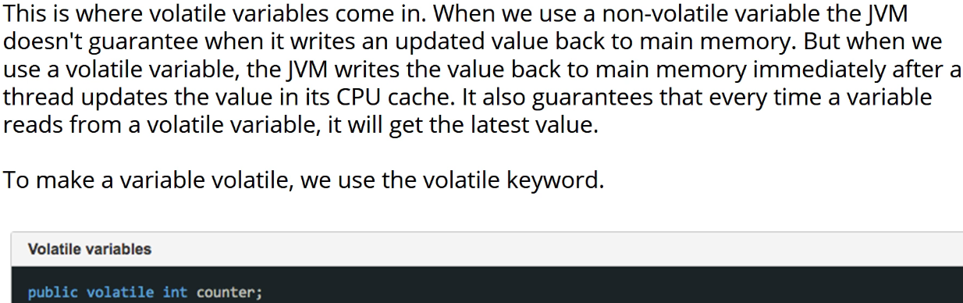

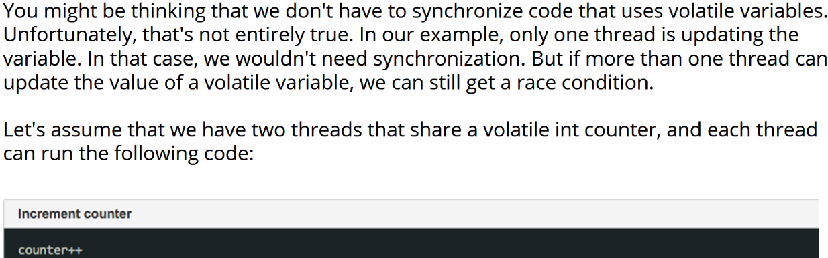

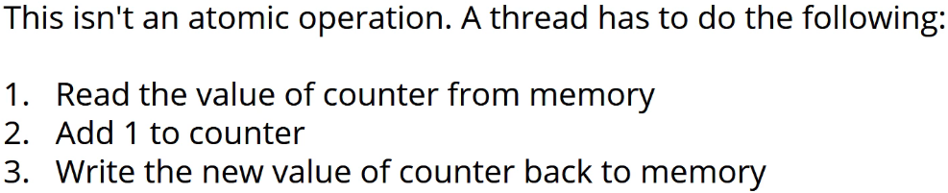

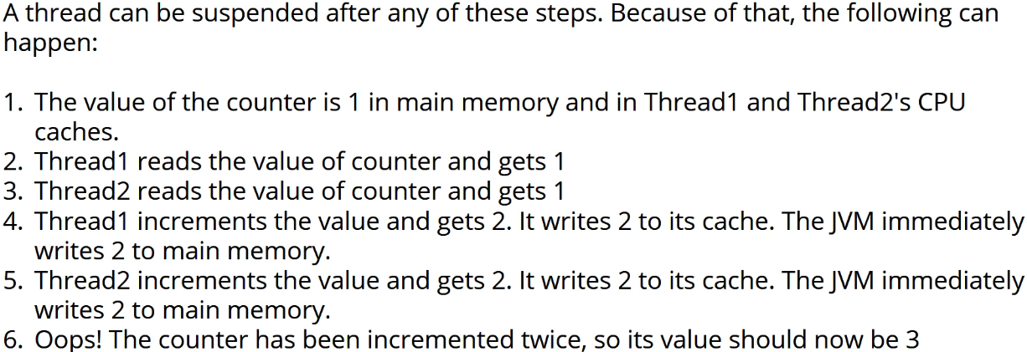

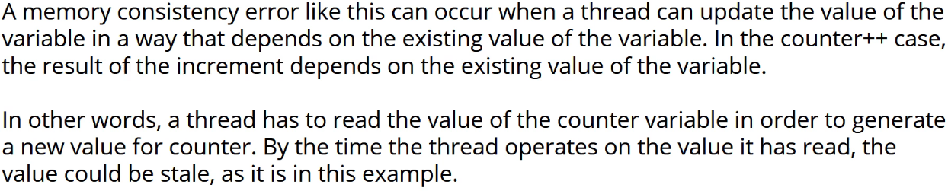

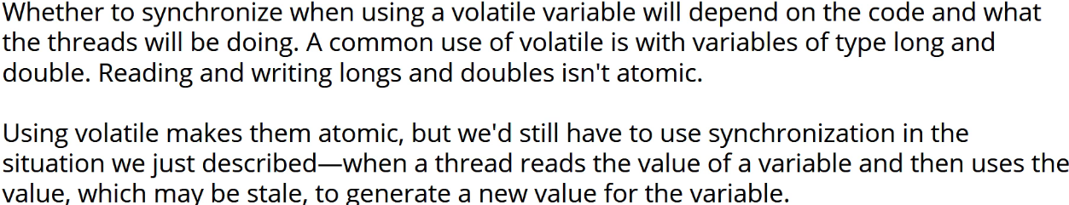

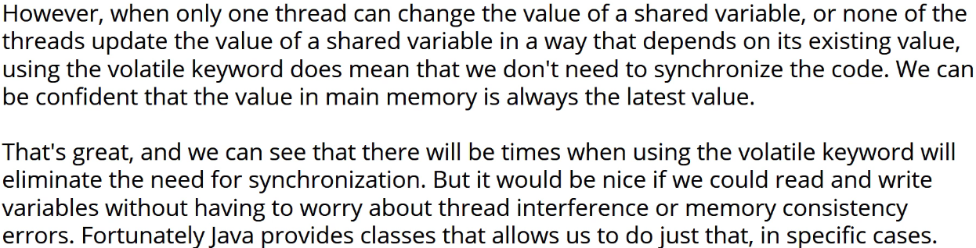

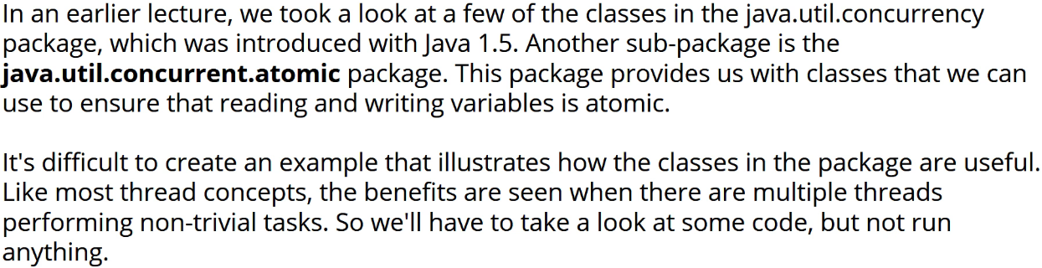

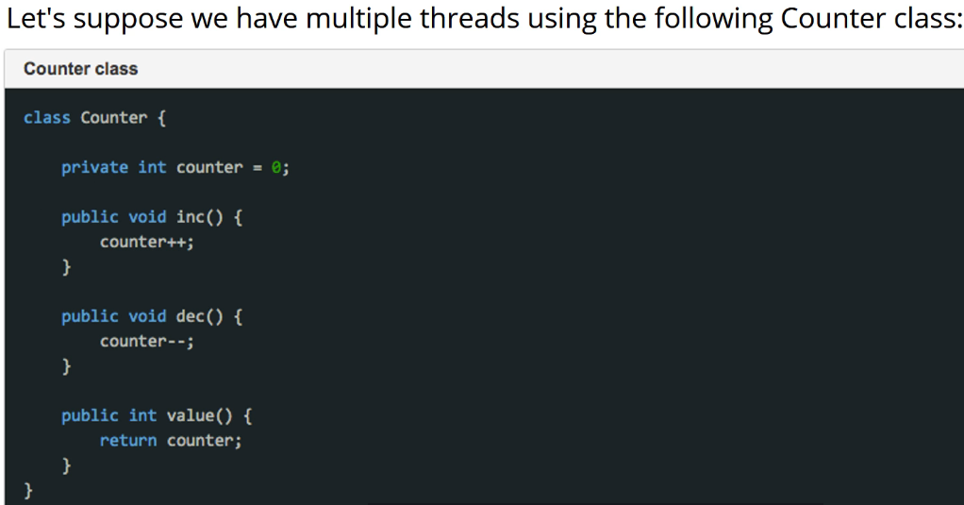

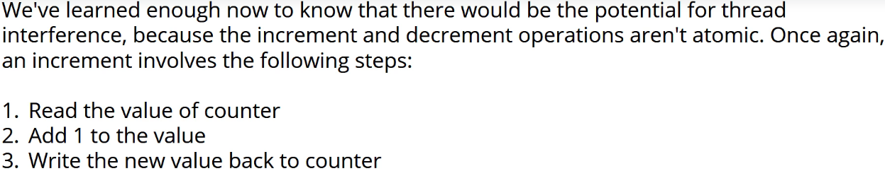

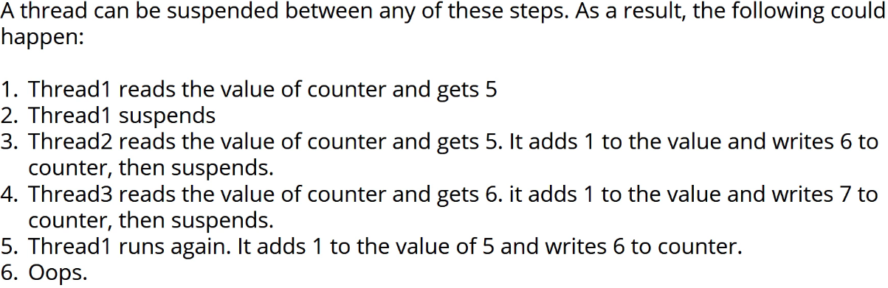

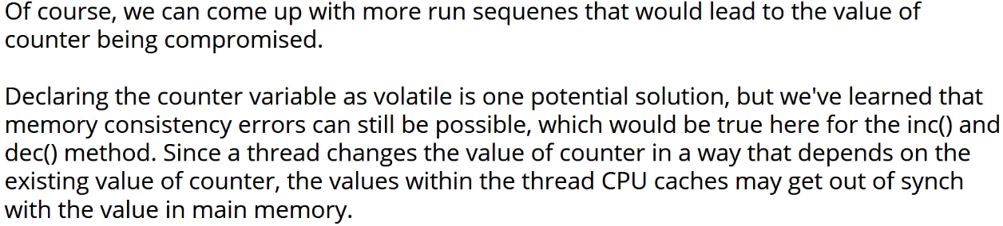

* **volatile**

* **AtomicInteger  
* incrementAndGet()  
* decrementAndGet()  
* get()  
* compareAndSet()**

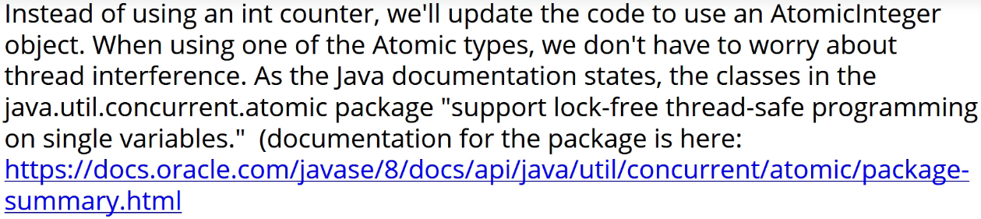

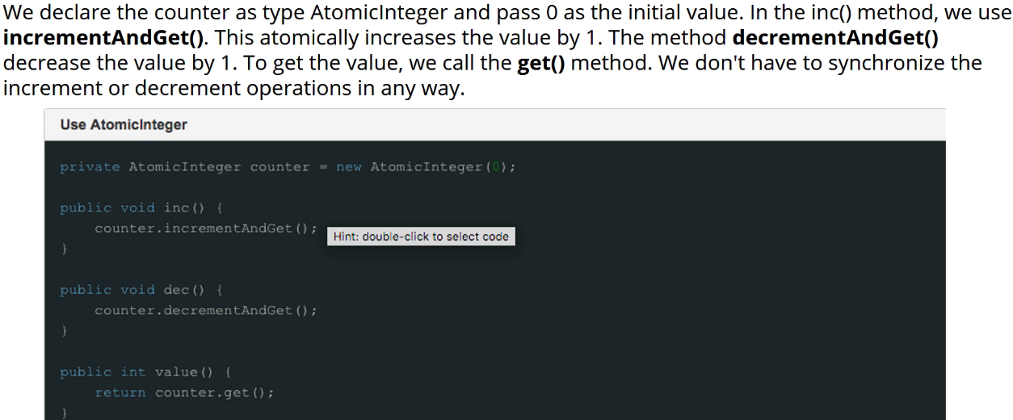

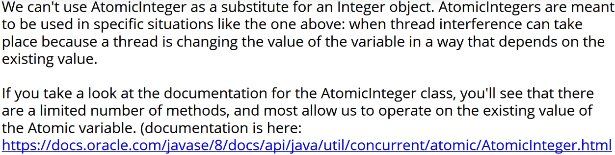

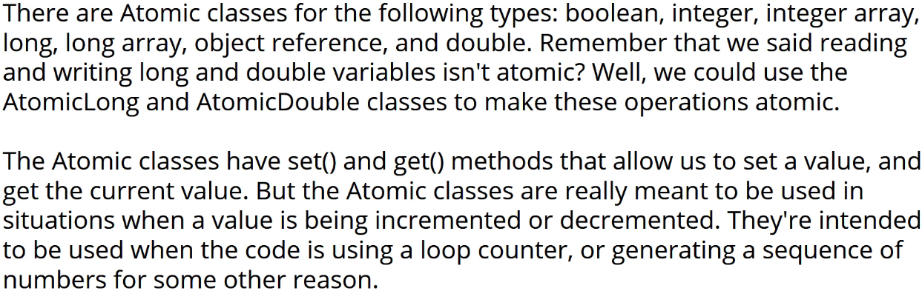

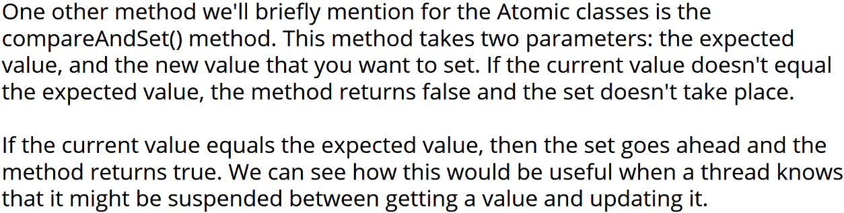

**JavaFX Background Tasks**  
* When we want to perform a JavaFX background task, we use a class that implements the Worker interface or a class that extends the Task class. The Task class implements the Runnable interface.  
* We’re gonna simulate fetching data from a database on a background Thread which is a common situation in a UI application.  
* Another example would be fetching data from the internet.  
* The sleep() is simulating the database fetch.  
* For simplicity we’re ujsing throws Exception while in a real application you’d probably want to catch it and so something with it.  
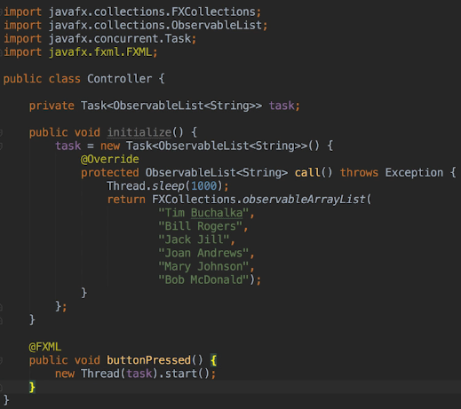  
* sample.fxml  
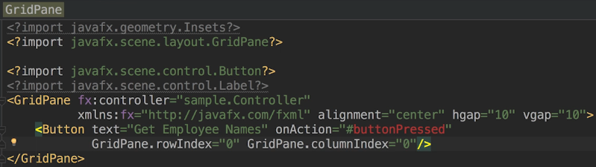  
* We can only access UI controls on the main Thread, the JavaFX application Thread that is, because the controls themselves aren’t Thread-safe. Rather than making them Thread-safe, JavaFX enforces the rule that all code that touches the user interface must run on the JavaFX application Thread. That way Threads can’t interfere with each other when updating a UI component.  
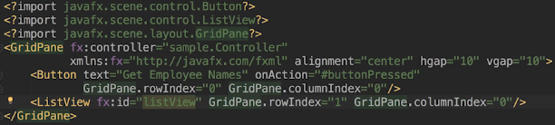  
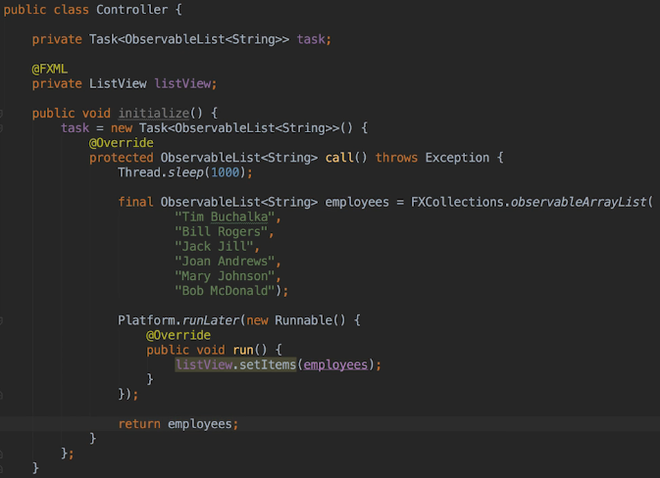  
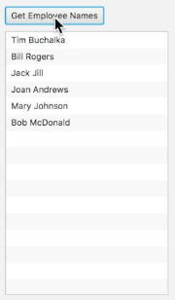  
* In general the UI code and the code that processes data should be kept separate.  
* The recommended way instead if using Platform.runLater() we can use what’s called Data Binding. So the Task class has a property called value which is the value returned by the Task. In our example it would be the ObservableList<String>. The ListView control has a property called items and that contains the items that the ListView is displaying.   
* What we’re going to do is bind the items property in the task’s value property. Whatever the value property changes, the items property will update accordingly. We no longer have to explicitly update the ListView by calling Platform.runLater().

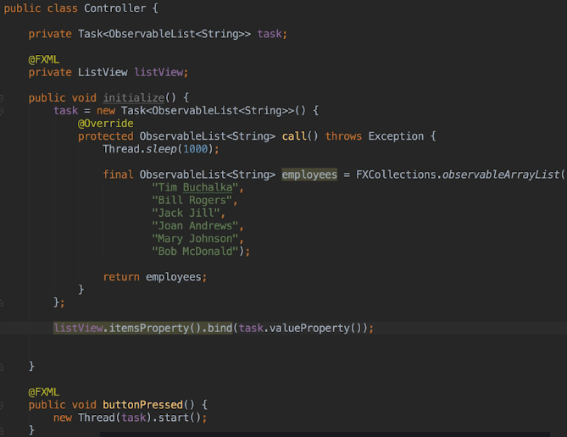  
* So after declaring the Task, we bind the ListView’s items property to the Task’s value property.  
* So it works, we’re performing a long-running Task on a background Thread and updating the Task on the UI Thread.  
* Better yet, the Task doesn’t know anything about the UI. All it’s doing is returning a list of names and it doesn’t actually care what happens to it after that.  
* So the list can be written to a file, displayed on the screen, printed to the console or used for something else. It actually doesn’t matter to the Task code and it’s not tied to the UI in any way.  
* So we can do other things with Tasks such as passing parameters to them and executing code when they’re completed. You can check the Task documentation to read more about them.  
* Let’s enhance this application in the next video. Let’s just imagine that it takes 10 seconds to fetch a large group of records from a slow database, would be great to have a progress bar so that we can see that something’s working and that the update is happening.

**Data Binding**  
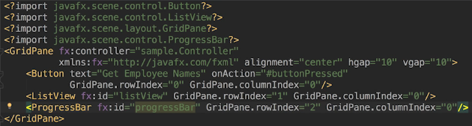  
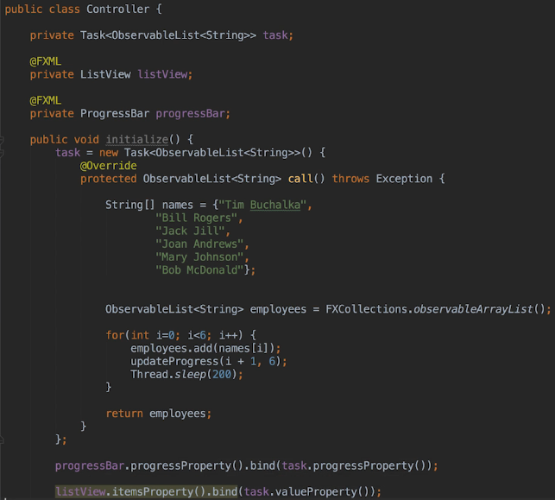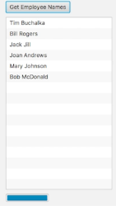* Right now before we click the button, there’s the indefinite progress bar.  
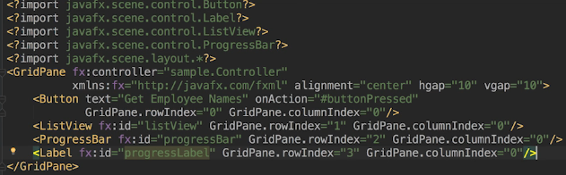  
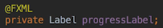

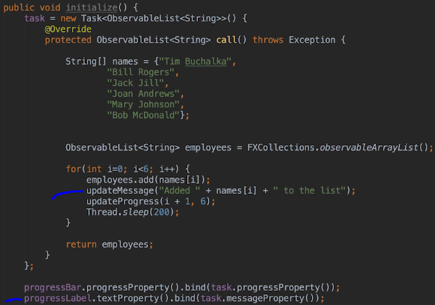  
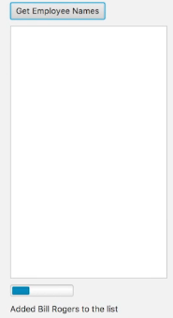 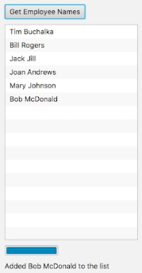  
* So JavaFX is designed to use properties in this way.  
* So when you want to update the UI control whenever the value of something else has changed or set, do check the documentation to see if what you want to update and the source value can be bound together because it’s a great way of doing it and you are leaving the JavaFX framework to do the heavy lifting.  
* Before we leave this topic, let’s take a look at the Service class which we can use to execute a Task on a background Thread, so it’s there to help developers use background Threads correctly in a UI application.  
* We can start and cancel the Service and unlike a T hread, we can also restart the Service.  
* So let’s change our example to use the Service.  
* The first thing we need to do is add a sub class of the Service class to the controller. So we have to create a method called createTask() in our sub class.  
* Instead of creating our Task instance in the initialize() method, we’re going to create it in the Service’s createTask() method instead.

**Service**  
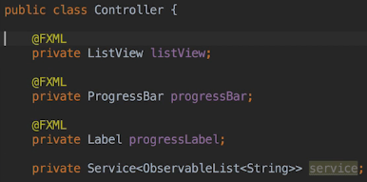  
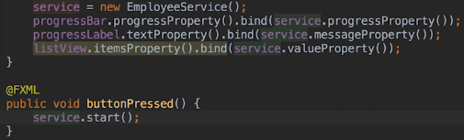  
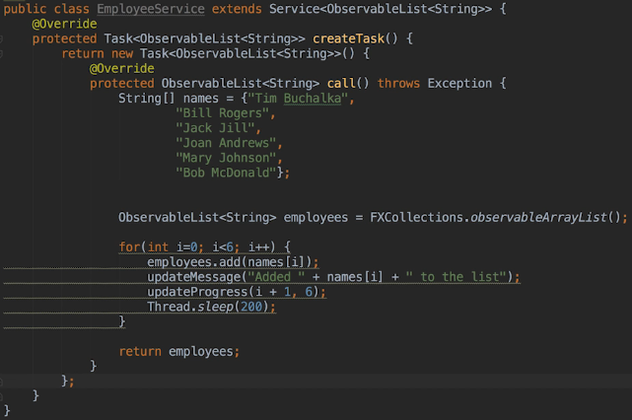  
* If we run it, we see the same results as before.  
* This is the recommended way to work with Tasks in JavaFX.  
* Using a Service allows the JavaFX runtime ot manage Threads for us.  
* If we click the button again, we get an erorr: **InvocationTargetException**  
  
* We can restart a Service multiple times but it must be in the READY state when we start it.  
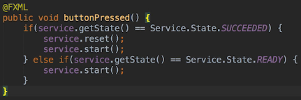  
* If you keep clicking the button, it’s gonna ignore the other clicks and process only the current one.  
* Service class has methods that allow us to run code every time the state of the Service changes. So we could hide the progress bar and label when the application is initialized.

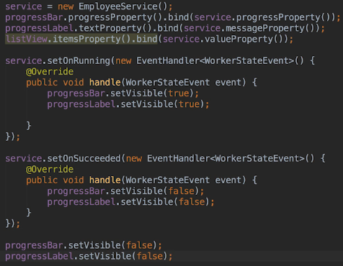  
* Remember that I said when we’re tying 2 things together, meaning that we want one thing to change when the other thing changes, we should always check the documentation to see if we can accomplish what we want to do by binding properties together. Well in this case we’re tying the visibility of the progress bar and label to the running state of the Service. So can bind the 2 things together rather than using a setOn method? Yes we can. So we can change our code:  
  
* The code is much simpler.  
* We often need to uise the setOn methods because we wouldn’t always be able to accomplish what we wanted to do by just binding the code to the Service’s running property. But if you’re doing something that’s relatively straightforward, you can see that it’s a more elegant solution, using a lot less code.  
* One last note - if you want to pass parameters to the Task that the Service runs, we have to expose those parameters as properties of the Service sub class. Now since properties are a general Java topic and not a JavaFX topic, we won’t discuss how to do that in this lecture but I just wanted to make you aware that it is possible to pass information to the Task by adding properties to the Service sub class.  
* Let’s now hopefully solidify the understanding of Java Concurrency.

**Challenge 1 and 2**  
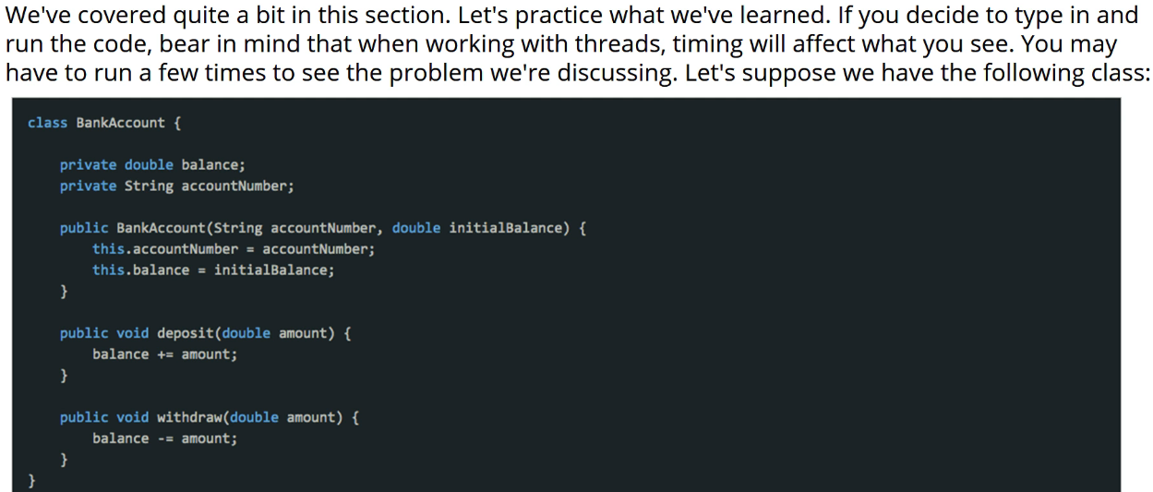

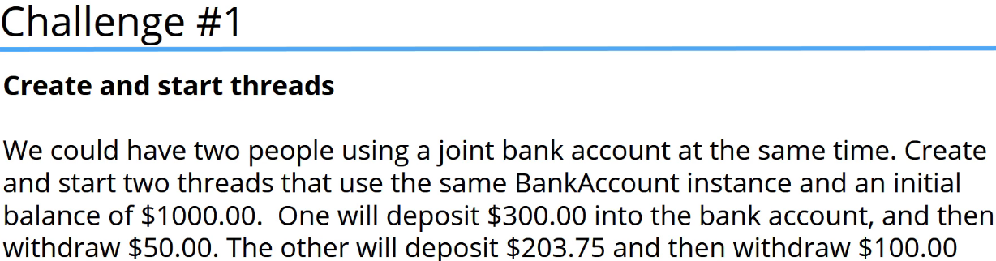  
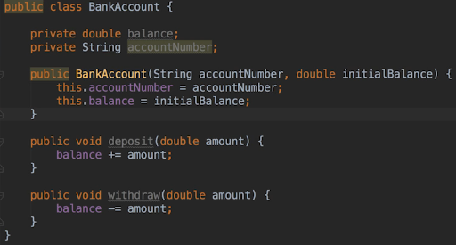  
* There are 2 ways we can create and start the Threads.  
**1) => Extend the Thread class and implement the run() method - or an anonymous class**  
* It wouldn’t make sense to have the bank account class extend Thread because each transaction on a bank account will be different. If we wanna create the Threads by extending Thread, we use anonymous Thread classes.  
  
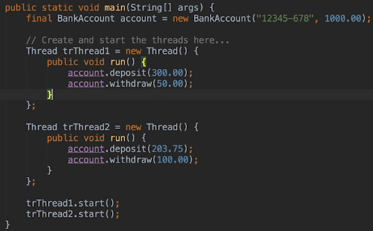  
**2) => The second way is to create and start Threads to use the Runnable interface**  
* Again it doesn’t make sense to have a bank account class implement Runnable, so we’re going to use anonymous Runnable instances.

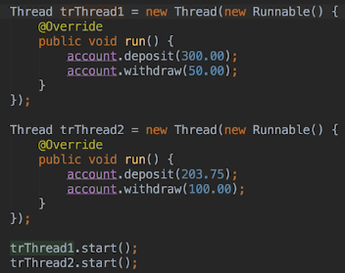  
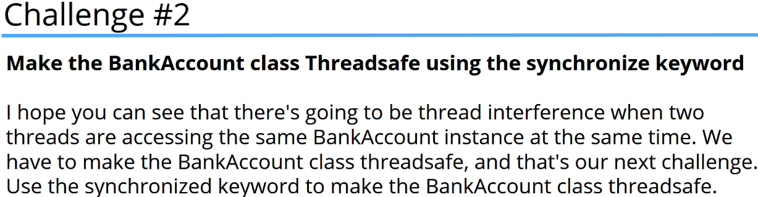  
* There are 2 ways of doing this.  
**1) => Add synchronized to the method definition**  
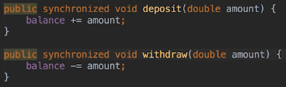  
**2) => Use the synchronized block to synchronize the code within the methods using THIS**  
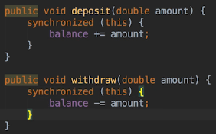  
* If the methods contained more code and not all the code was a Critical Section, the 2nd solution would be a better solution.  
* Remember that generally speaking we want to synchronize the smallest amount of code possible to minimize the performance impact on the application. So we only want to synchronize an entire method when all the code within the method is a Critical Section.

**Challenge 3, 4 and 5**  
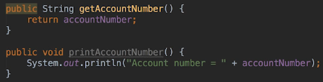

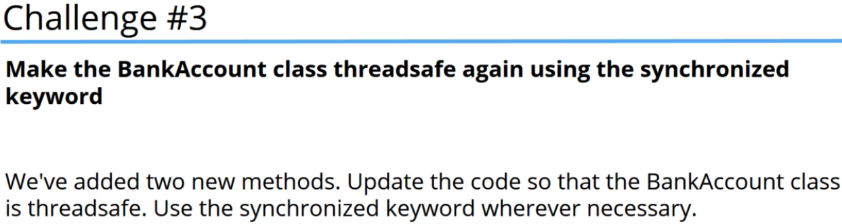

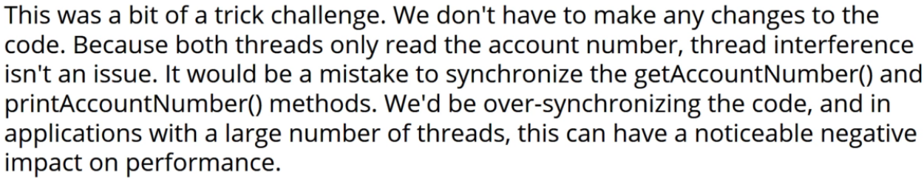

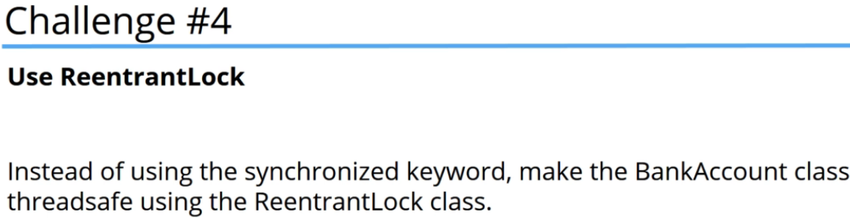

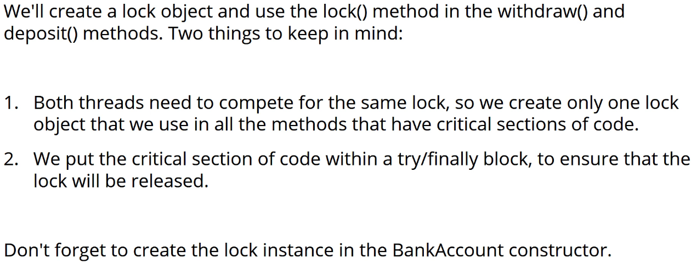

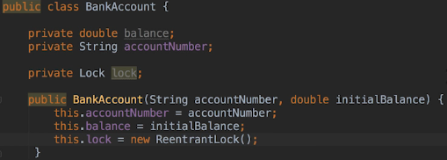  
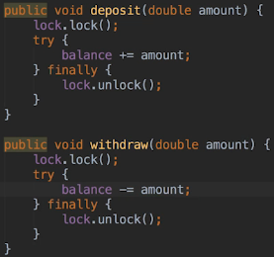

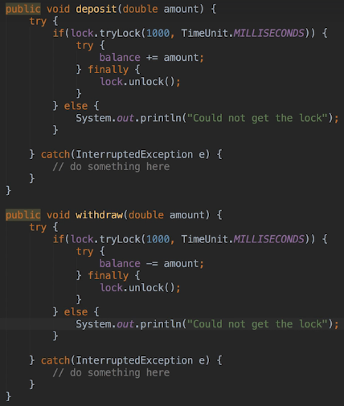

**Challenge 6 and 7**  
* Let’s make a change to both the deposit() and withdraw() methods.   
=> We’re gonna add a status variable to both methods. We’re going to initialize it to false and if the Thread gets the lock, we’re going to set the status variable to true and at the end of each method we’re going to print the status to the console.  
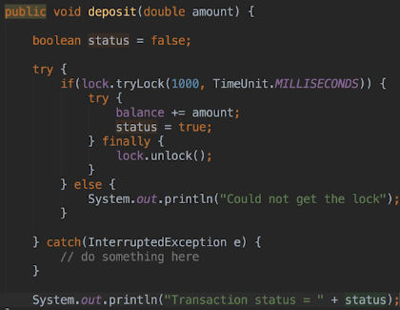 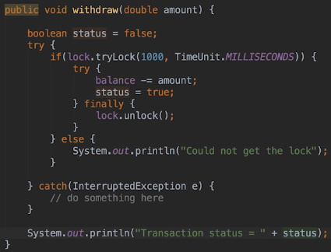  
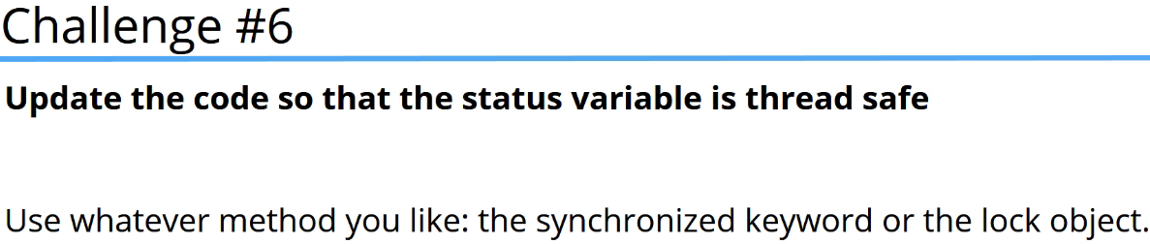

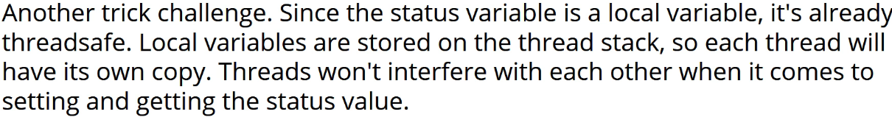

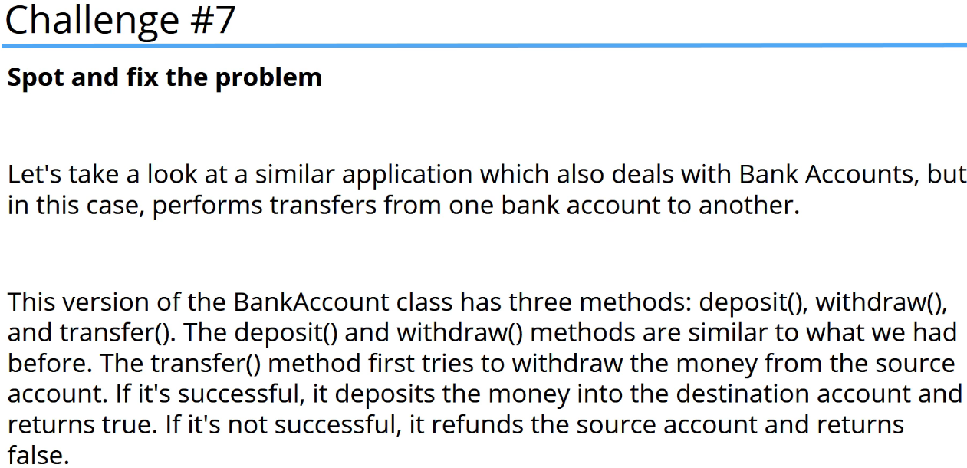

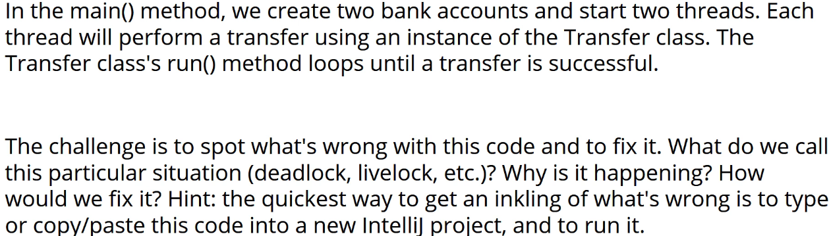  
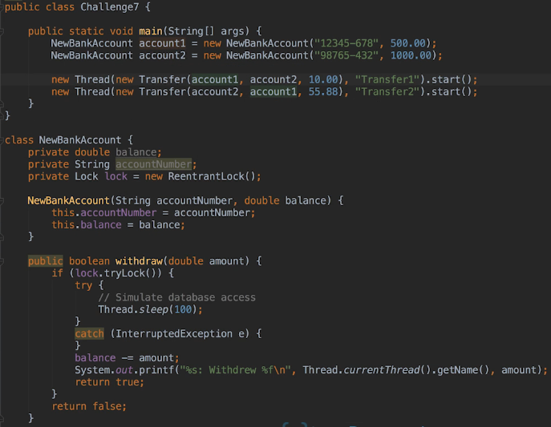

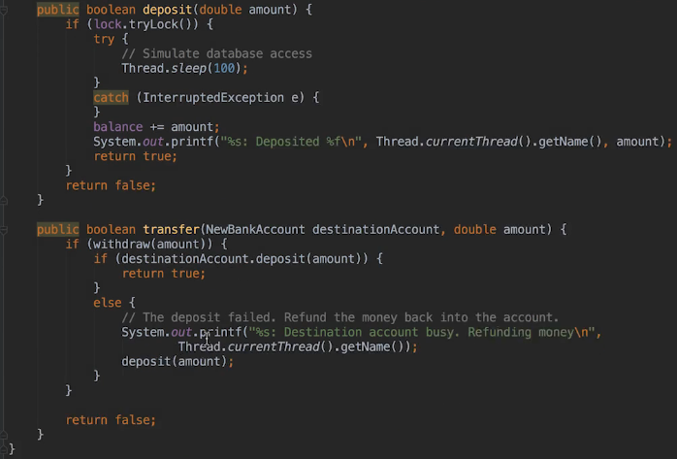  
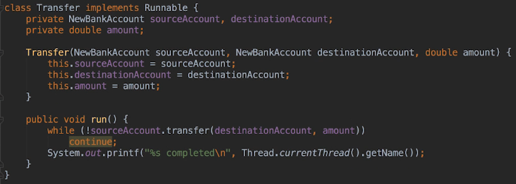  
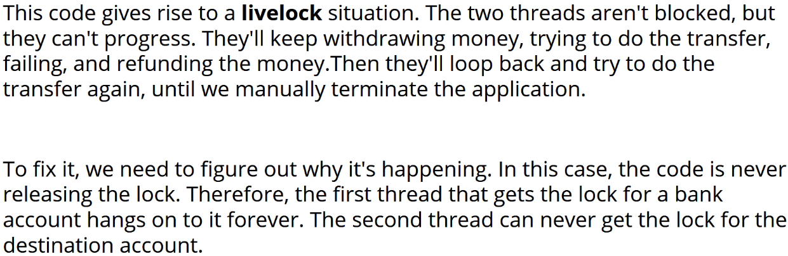  
* Here’s one potential sequence of execution:  
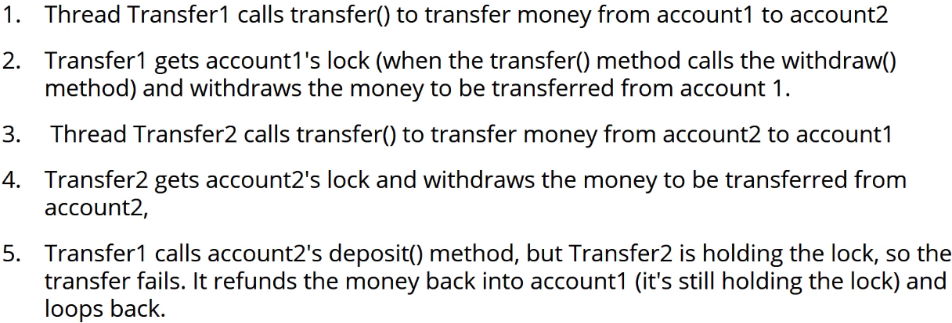

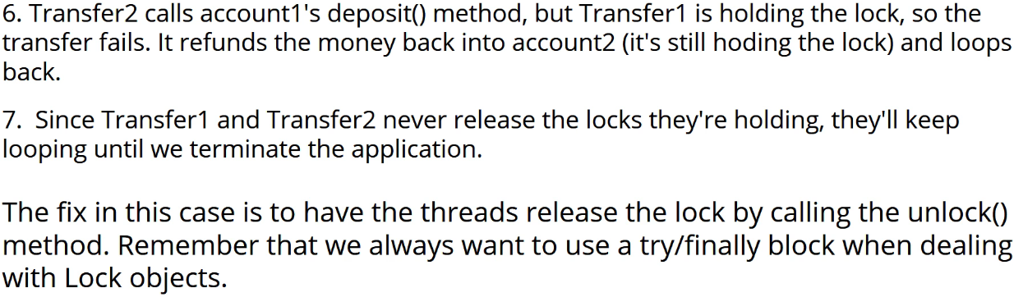  
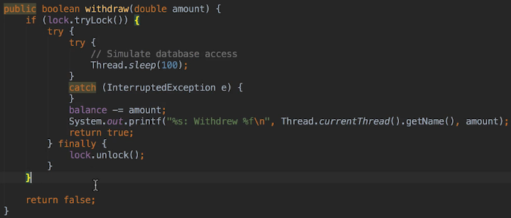  
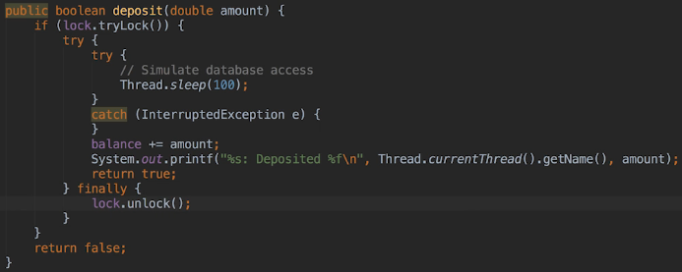  
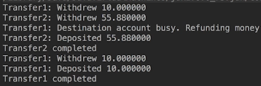

**Challenge 8**  
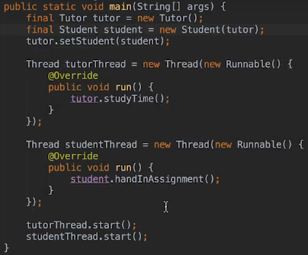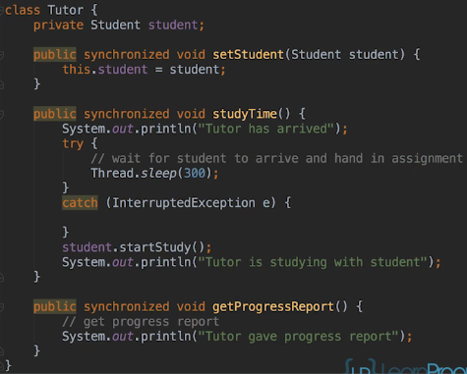  
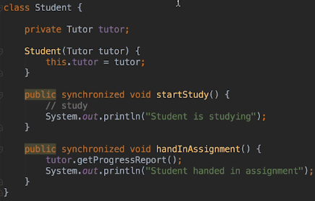

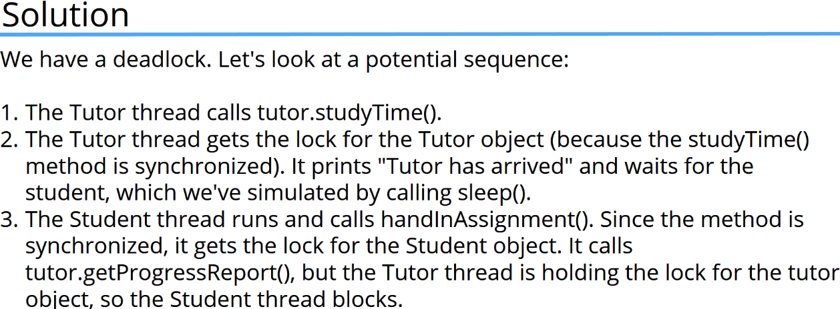

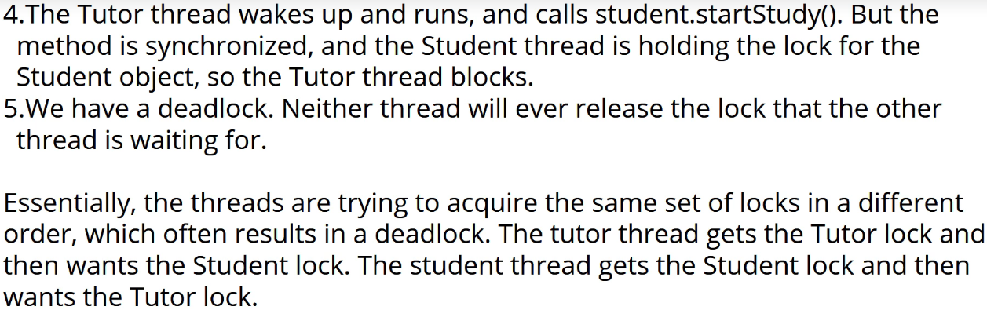

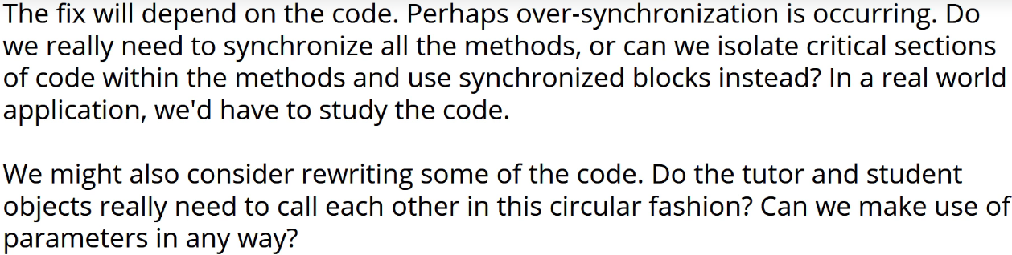

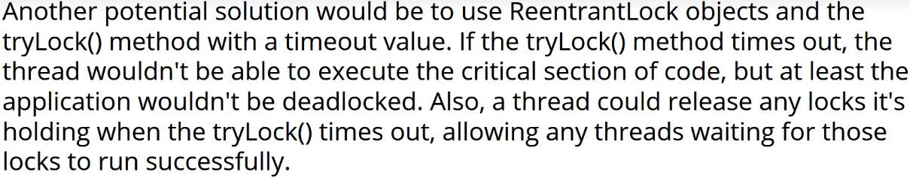

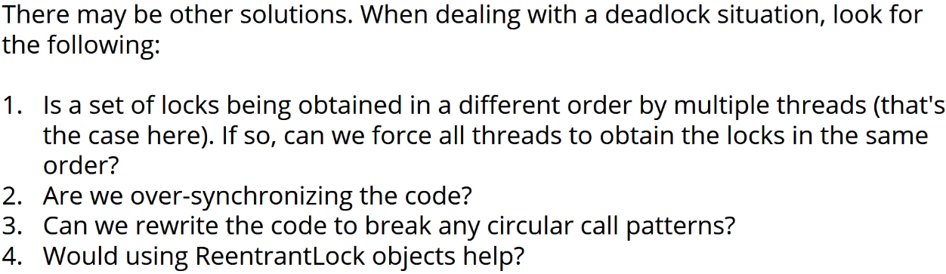

**Challenge 9**  
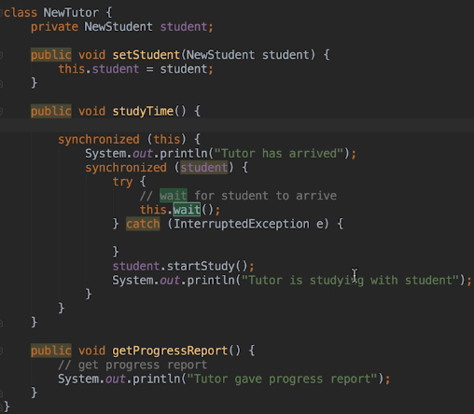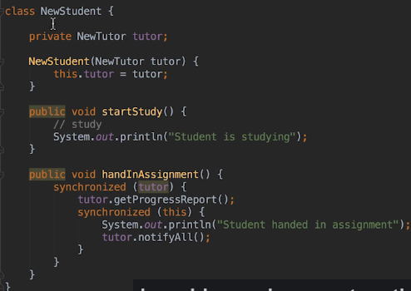  
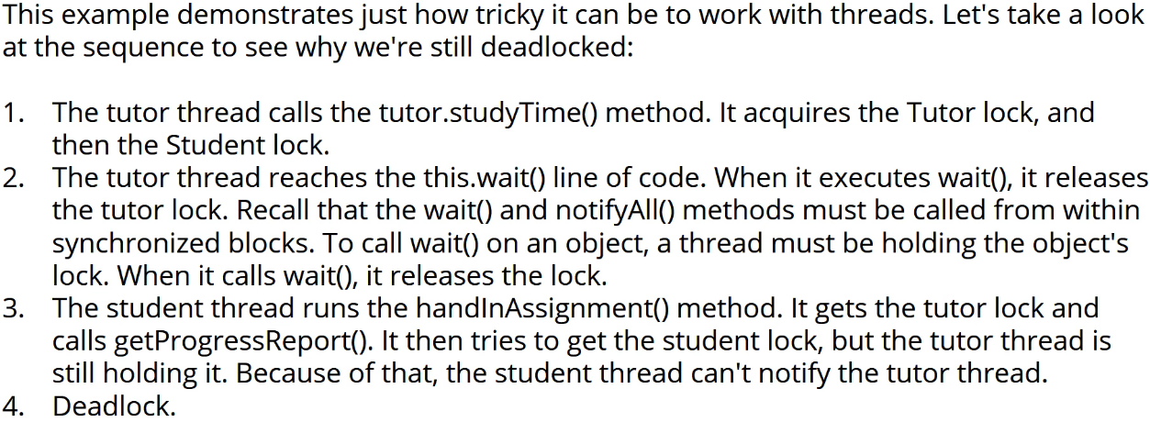

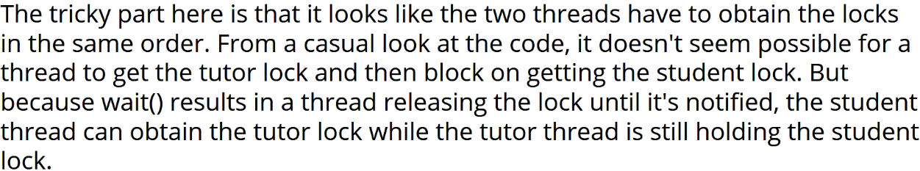

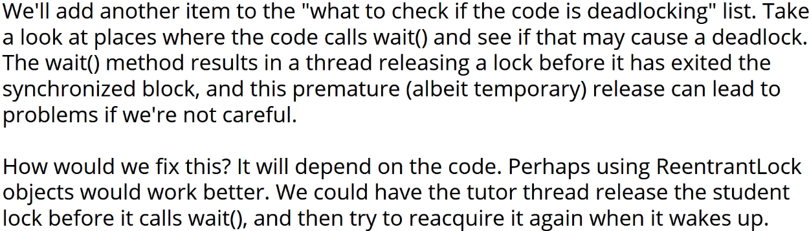

**Resources**  
Class Thread  
<https://docs.oracle.com/javase/8/docs/api/java/lang/Thread.html>  
Class Collections  
<https://docs.oracle.com/javase/8/docs/api/java/util/Collections.html#synchronizedList(java.util.List)>  
Class ArrayList<E>  
<https://docs.oracle.com/javase/8/docs/api/java/util/ArrayList.html>  
Interface Lock  
<https://docs.oracle.com/javase/8/docs/api/java/util/concurrent/locks/Lock.html>  
Interface ExecutorService  
<https://docs.oracle.com/javase/8/docs/api/java/util/concurrent/ExecutorService.html>  
java.util.concurrent.atomic  
<https://docs.oracle.com/javase/8/docs/api/java/util/concurrent/atomic/package-summary.html>  
Class AtomicInteger  
<https://docs.oracle.com/javase/8/docs/api/java/util/concurrent/atomic/AtomicInteger.html>  
Class Task<V>  
<https://docs.oracle.com/javase/8/javafx/api/javafx/concurrent/Task.html>